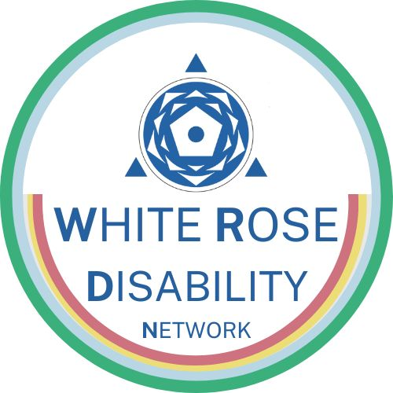

Welcome! We are the White Rose Disability Network, a collective of Post-Graduate and early career researchers, activists, and advocates based across the White Rose Universities.

This blog post hopes to capture three of our core principles and give some insight as to our upcoming events!

- Building community
- Varied means of engagement
- Member driven

Having met at Postgraduate Researcher (PGR) conferences and our various institutions, we recognised a collective desire among PGRs and early career researchers for more engagement with disability activism beyond the scope of Universities.

The inherent historic connection between Critical Disability Studies and activism, which is sustained through conscious work. Communities do not ‘just happen’, and this is arguably the central aspect of our endeavour.

In the spirit of this, our debut event last year was the Anarchism and Activism: Disrupting Disability Conference. The aim of this event was to highlight the work of activists, and discuss how to build more supportive relationships between academics and community organisers. There was an evident appetite for this, as the call for papers was met with enthusiasm from the community, and gave us the opportunity to highlight four themes across our panels (Grassroots Activism, Intersectional Activism, Scholar Activism, and International Advocacy).

Our second priority, promoting differing forms of research and experience communication, is a common issue in research communities. We believe that this is particularly important for Disability research, in terms of being accessible to all but also through our desire for our events to be an enjoyable and restorative experience.

The topics discussed in our research are often related to lived experiences and academic institutions are frequently critiqued for their systemic ableist tendencies, often with resources behind restrictive paywalls. By providing spaces where alternative means of communication can be explored, we help to engage in a more sustainable and inclusive form of knowledge production. One example from our last conference is Firielle Al Jubeh’s powerful use of movement as a means of describing her engagement with activism for disabled Palestinians. Alongside this, we were able to distribute zines produced by the Disability Action Research Kollective. Sharing these alternative forms of communication means we can move the discussions about important intersectional figures to a more accessible format, outside of often paywalled or inaccessible, academic journal articles. This means of research communication is something we want to bring into our future events, and shall be hosting a zine workshop in the near future!

Finally, our Network direction and event themes draw on the experiences and interests of our members and audience. We want to ensure that we are hosting events that really cater to the communities we’re engaging with, addressing the contemporary priorities of the Disability Rights Movement. As such, the theme of our upcoming event will be exploring hate and hope, and how we navigate disability in the face of the growing far right animosity.

We welcome and encourage collaboration with DPOs, artists, and community organisers, and are always looking to foster new collaborations. Get in contact with us at whiterosedisabilitynetwork@gmail.com for any questions, or to join our mailing list and stay up to date on our latest events!

Written by Leo Woodend on behalf of the WRDN Team

To join, follow the QR code OR to join, follow this link.

