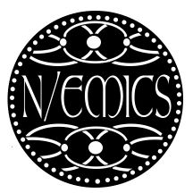
Texture in the Medieval World
Interdisciplinary Conference
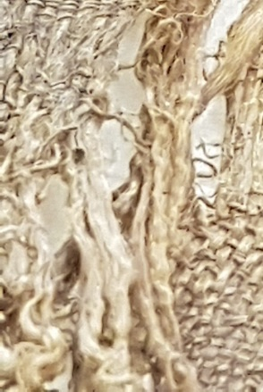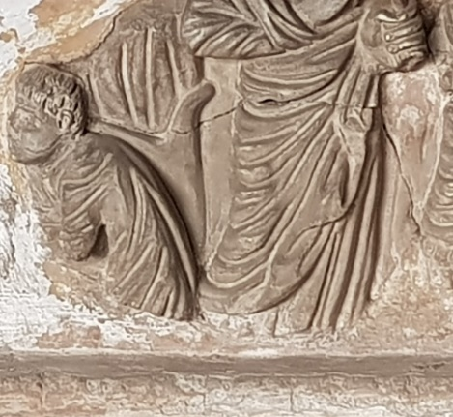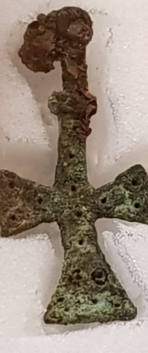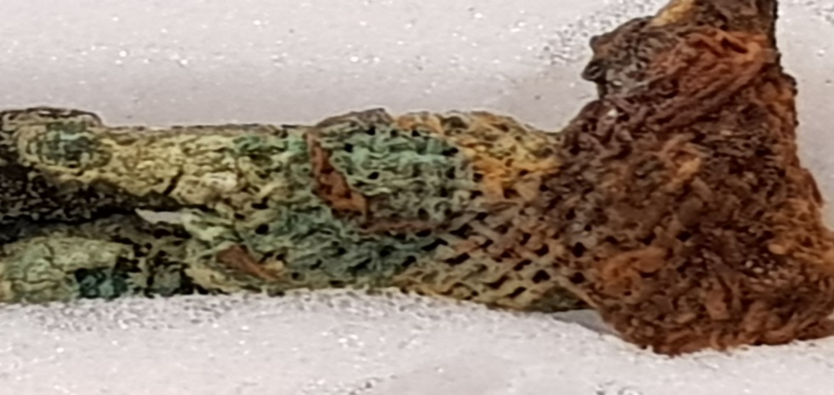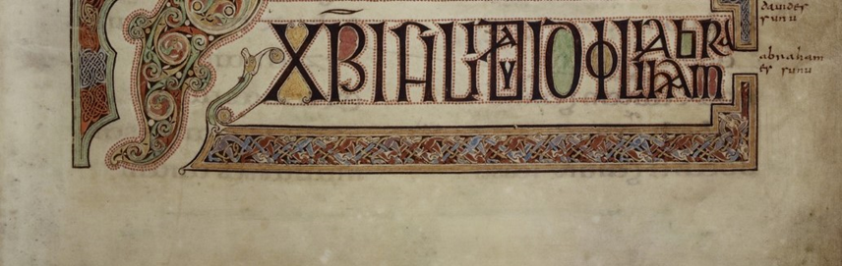
Centre for Medieval Studies, University of York
1-2 June, 2024

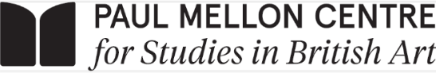



Building on the past success of N/EMICS events, this, the 21st conference of this research series, considers the possible visual and conceptual approaches to Texture in the Medieval World in its widest possible contexts, through examining written, archaeological, pictorial, architectural, geographical, cartographical and liturgical material in order to shed new light on the uses, understanding, purposes, and transformations of texture in the Middle Ages. The interdisciplinary, two-day conference focuses on the visual, conceptual and haptic qualities of textual and visual material and their importance and use in the medieval world. In order to explore the relationship between text, texture and materiality papers will explore
ideas of; decoration, colour or luxurious materials; manipulation of texture and materiality through skeuomorphism and symbolism or as exegetical devices; the role of texture and materiality in conveying status, wealth and power in textual, social and material contexts and physicality, presence and scale whether actual, imagined or implied. Themes will include: craft, technique and process; finished/unfinished; fragments; fraying; fabric; threads; woven, interwoven; embroidered and embellished; edges and borders; webs; networks and exchanges; thus lending itself as a topic to multiple interpretations across various media. This conference (re)considers various facets of textural constructions and understandings in the medieval past, as viewed from the present, seeking an interdisciplinary approach to this topic - including ideas of how texture and depictions of it change over time, and the significance of these changes to the construction of past structures and narratives. By reaching across boundaries of discipline and period, this conference
provides a forum for the sharing of ideas, and the exploration of new thoughts on texture. The conference crosses various disciplines and periods, bringing together emerging scholars working across several fields of research with established academics, to provide a platform for the reconsideration of the idea of “texture” in its widest possible connotations.

The organisers would like to thank the History of Art Department and the Medieval Art and Medievalisms Research Cluster (University of York), The Paul Mellon Centre for Studies in British Art and The Viking Society for their help towards funding the conference.

Saturday 1 June, 2024

9.00-9.30. Registration and Coffee, The King’s Manor, Room K/G33

The conference will take place at The King’s Manor, room K/133

9.30-9.45 Welcome and opening remarks

9.45-10.45 Session 1: The Elementary and the Sensory. Chair: Meg Boulton
Jessica Gasson
‘A fountain of living water that springs from Lebanon’, weaving water and other technical challenges in the facture of the Living Water tapestry, 1485
The Living Water tapestry is densely and richly woven with gold, wool and silk threads dyed in many colours. In the Living Water tapestry the representation of water is more texturally than optically imitative – smooth pale blue silk threads are used, bunched into bundles to create the puckering of ripples, striations of silver threads create gleam of light on water, single picks of white above the brown of the riverbed create a gauze to show translucency. These are all techniques that cannot be rendered with oil paint. Without a handbook like Cennini’s Il Libro dell'Arte we must look very closely at the weave structure of surviving tapestries to understand how surfaces and textures wore broken down to be rendered in wool and silk by weavers. Looking closely at these techniques I argue that weavers’ repertoires for rendering textures expanded rapidly in the 1470s to show intangible surfaces: clouds, sunlight, shadows, and water and that these techniques facilitated the creation of liturgical tapestries with more sophisticated iconographies that incorporated their materiality into their meaning.

Adriana de Miranda
Abstract Texture Decoration in Water Installations (Zoom presentation)
The water-wheel represents the most elegant of hydraulic devices. It is an installation which, using the power of the river, raises water to irrigate fields which are usually at a higher level than the level of the water. It was widespread in the Middle Ages in the Islamic Mediterranean and has played a particularly significant role in combining design and efficiency. Its mechanism has been able to be easily combined with different shapes which display sophisticated forms of construction. This paper deals with the geometric texture of the wooden wheel in Mediterranean lands, which is strongly linked to the strength of the river current. Polygonal shapes deal with weak river currents, and can be found on the Segura valley in Spain. The wheels with a radial shape are able to support a reduced river power, like in the Quwayq valley in northwestern Syria. A combination of radial and polygonal motifs is evident in Turkey on the Tarsus river characterised by a consistent current. A texture with a “polycentric” radiality characterises the wheels which deal with a strong river power, like those in Western Syria on the Orontes river. The paper also investigates the connection between the pattern of the water-wheel and the Islamic geometric decoration in some works of Art, such as screens, panels, doors, tiles, carpets, dishes and bowls.

10.45-11.15 Coffee Break

11.15-12.45 Session 2. Dressing the Ecclesiast. Chair: Tracey Davison
Maria Giorgi
The extraordinary vestment of San Panfilo (Zoom presentation)
A chasuble, which is of extraordinary quality, was found folded in a wooden reliquary in Sulmona Cathedral with a knitted red silk bag decorated with Chinese knots containing bones and a pair of leather boots, with borders in silk, metal thread and lined with linen. Indeed, the vestment is quite equivalent in the whole composition to the Lucca textiles (12th and 13th centuries), with the exception of the inscriptions; which lead us to believe a production from a Califat culture brought through Syria, Palermo and Spain. The chasuble is a production prior to the manufactures of Lucca, however linked to the diaspora of the Moors in Palermo, who introduced technique and decorative motifs to the Tuscan city. These are probably Moorish weavers who were still operating in Palermo at the time of Frederick II, although the question remains open why a Christian sacred vestment presents Islamic blessings.

Juliette Calvarin

Embroidering Velvet: Textile Mimesis on a Fifteenth-Century Chasuble
Uppsala cathedral's remarkable Marian chasuble, entirely embroidered in silk, gold, and pearls on linen in the mid-fifteenth century, is a smorgasbord of texture. The chasuble centres on an image of the Virgin and Child enthroned on a crescent moon, surrounded by quatrefoil frames containing the 7 joys of the Virgin. All of these depictions feature, among other things, an array of different, and differently rendered, brocaded textiles, including a number of velvets stitched with a "velvet stitch," an embroidery technique designed to replicate the pile of woven velvet, variously combined with couched gold thread; velvet stitch also outlines the seven scenes and figures in the chasuble's embroidered background. Velvet stitch has been recognised since the 1920s as characteristic of a group of embroideries, probably of Swedish origin, now preserved in Swedish churches. The technique has not, however, been studied for purposes beyond attribution, and its semantic value has remained unexplored. Such a step requires combining textile analysis with iconographic and ritual study. This paper will start from a needle’s eye view, arguing that detailed attention to the object itself is key to decoding its technical vocabulary. Using the Marian chasuble as an example, I will first consider the extent to which embroiderers sought to replicate existing woven velvets, their motifs, and their structure. Second, I will interrogate the meaning of that mimicry, focusing on the connections established by the technique between the figures, their background, and the worn vestment.
Flavia Galli Tatsch
Transmedia, transculturality and Texture of Islamic fabrics in 12th century French sculptures (Zoom presentation)
In the 10th-13th centuries, the circulation of Islamic fabrics (tiraz) came largely from the Mediterranean, contributing to a shared culture of pre-modern societies. Made from silk and embroidered with polychrome and golden threads, Islamic fabrics were appreciated for their material qualities and the recognition of the techniques necessary for their manufacture. Its circulation was largely stimulated by trade, the exchange of gifts and as spoils of war. This paper will allow us to reflect in new ways on the tiraz that circulated in France, considering the portability as a fundamental element of their transnationality, transculturality, and texture. These objects circulated on French territory as objects in themselves (the shroud of Saint-Lazare, the chasuble of Saint Exupère), most of them kept in the treasures of the churches and whose visualization was limited in time-space; and as object-image, carved in Jamba statues (Chartres) and in the tympana of churches (Conques), which escaped the liturgic performance and were present to a much wider public. The appearance of fabrics in the sculptures occurred through the transfer of the same types of ornamentation that were found on the original supports, such as addorsed birds, animals inserted in medallions, palm trees, elements of court culture (such as falconers), Arabic inscriptions of good auspices, geometric motifs, or types of clothing folds.

12.45-2.00 Lunch Break

2.00-3.30 Session 3. Painting Textile. Chair: Jeremy Melius

Chiara Stombellini

From Transmateriality to Mise en abyme: Artistic Representation of ‘Panni Tartarici’ in Fourteenth-Century Venice

Once considered mainly as bi-dimensional works of art, fabrics are instead polyhedric objects: because of their materiality, they could be easily carried, (un)rolled, and exhibited, being often responsible for artistic transmission. Textile studies have explored their representation on different supports, whether it be the depiction of woven or embroidered artifacts within a figurative scene or the “migration” of ornament from one medium to another. In this respect, medieval painters and sculptors faced the challenge of rendering specific aesthetic features of cloth using alternative materials. Nevertheless, in the Late Middle Ages, many artists were familiar with multiple techniques, facilitating this process. In 14th-century Venice, a vibrant dialogue between arts flourished, driven by a trade-based economy where the circulation of objects and know-how had a central role. Local artists such as Marco, Paolo, and Lorenzo Veneziano engaged in designing embroidered altar frontals, stained glass, and, likely, mosaics for St. Mark’s Basilica. Their mastery in depicting silk cloths across media reflected the prevalence of ‘Panni Tartarici’, Mongol textiles infused with Chinese and Islamic patterns, featuring extensive use of gold threads. Despite their significance, their presence in Venice has been often overlooked. Focusing on Late Medieval painters, this paper investigates the representation of Mongol fabrics in Venice. Through detailed analysis, it explores the translation of textile materiality onto different supports, encompassing texture, colours, and light effects. By unravelling the intricate interplay between the object and its artistic reproduction, this study aims to shed light on the impact of cloths in the elaboration of Venetian visual culture.
Chiara Demaria
A guide to ‘contraffare’ textures: Cennini’s Libro dell’Arte and 14th-century Tuscan painting (Zoom presentation)
Unlike other treatises on medieval painting, the Libro dell’Arte by Cennino Cennini, a Florentine painter of the late 14th-century, offers the reader not only instructions on how to prepare and apply the colours but also on how to accurately convey (contraffare) through painting, the tactile and visual characteristics −specifically, the texture− of different materials. Cennino explains how to depict natural elements such as skin, water, wood, mountains, vegetation, stars, as well as various types of luxurious fabrics, such as brocades, velvets, and woolen cloths. The Libro dell’Arte was written at the end of the 14th century, a period that witnessed the emergence of naturalism in painting during its first half, thanks to the remarkable contributions of the Florentine and Sienese schools. This tendency was aptly described by the epithet naturae symia, attributed to Stefano Fiorentino, a Giotto’s pupil. Cennino's instructions on imitating textures find copious validations in 14th-century painting: this paper aims to highlight some of them, considering also the context in which the paintings were executed. Sienese painters, in particular, excelled in their ability to depict materiality. Simone Martini elevated the description of fabrics by introducing numerous innovations in gold manufacturing, such as the technique of punched sgraffito. Another Sienese painter, Ambrogio Lorenzetti, the most talented landscape portraitist of his time, had some brilliant mimetic insights, such as using silver foil in tempera painting to evoke the impression of flowing water- an idea later adopted and reinterpreted by his brother Pietro in his depiction of a block of ice.

Rebekkah Hart
Salome and the semiotics of coral, blood, and paint
Jacob Cornelisz Van Oostsanen (1472/77-1528/33) painted Salome Holding the Head of St. John in 1524, manipulating materials to support metaphysical meaning. Salome holds the saint’s severed head out to the viewer, viscous blood dripping from the open wound into a charger below. These beads of blood form discrete spheres like a string of coral beads, echoing the delicate rows of coral that adorn Salome’s headpiece. Thus, both heads—Salome’s and the disembodied one she holds—are bedecked with coral and coral-like substance, rendered in the mimetic representation of oil paint. This paper analyzes the way that the artist used oil paint to index blood, which, in turn, indexed coral, to augment the painting’s narrative of metamorphosis. Oil paint is itself the product of transformation: the paint begins as crushed, powdered pigments, which become liquid when they are mixed with linseed oil, only to become solid once more with a tacky, velvety texture. Van Oostsanen deftly uses mineral-based pigments to illusionistically represent both coral and blood, with textural and material slippage at the heart of the transformational semiosis eliding the three substances. Examining the physical and visual properties of oil paint alongside late medieval mythological and scientific sources on coral and its associations with blood reveals how this painting comments on material and metaphysical metamorphosis. Medieval viewers ultimately could have perceived John’s blood transforming to coral through masterful illusion of oil paint, extending the narrative of John’s own metamorphosis from living to dead, prophet to mute, head to icon.

3.30-5.00 Session 4. Early Medieval Textures. Chair: Hanna Vorholt
Tracey Davison
The silk scarves of York and Lincoln as signifiers of considered projections of the self
This paper examines a group of silk headscarves recovered from Viking-age York and Lincoln through their materiality and resultant texture and what that reveals about attitudes toward personal appearance and embellishment. The weave and decoration of the pieces will be viewed in the wider context of other textile remains recovered from those sites and for example, artefacts from Birka, Sweden as well as earlier Coptic textiles from Egypt. By comparing these geographically distinct, but functionally similar textiles I hope to demonstrate a commonality on the grounds of physical appearance. This in turn raises the question of: can an argument be made for an accepted format in terms of material, weave and texture for women’s headwear? By viewing them as commodities, desirable high-status items to be traded and acquired, we gain insight into the motivations of those who owned and wore them.
Francesca Pandimiglio
The Brocade of the Lombards
“Vestimenta vero eis erant laxa et maxime linea…ornate institis latioribus vario colore contextis” (Paolo Diacono, Historia Langobardorum)
The intervention includes an exhibition regarding the investigation of the invention, but above all the use and distribution, of brocade by the Lombard people. Threads and decorations that have been woven and woven into trimmings and artistic details that have given life to unique and very precious pieces. Right in the title the term contextis is reported, which derives from the Latin verb contexo, "to weave together" and Paolo Diacono explains to us that these fabrics were embroidered borders, with threads of different colours, made with the most varied motifs, in particular herringbone or lozenge patterns. A fabric, brocade, which has had incredible success throughout history, up to the present day. Details and minutiae of some fragments of fabrics found in some Lombard era burials in Italy and Europe will be examined.

Maren Clegg-Hyer
Texture, Materiality, and Missionary Work (Zoom Presentation)
One of the lesser-known sets of texts in the early Middle Ages are letters among early medieval English missionaries laboring on the Continent among their relatives to convert them to Christianity. Associated with the Bonifatian missions, these letters are a window into warm and supportive friendships in ecclesiastical circles of the eighth century. But the letters demonstrate that more than supportive words were shared. Supportive objects were also requested and sent: elaborate textiles and books, in particular. Specific references demonstrate the perceived usefulness of these objects – woven, embroidered, illuminated - in creating a texture or ambience of sacrality as well as status helpful to both the missionaries and their fledgling converts. The resulting webs of interchange documented in the letters highlight remarkable moments of textual and material nexus, but also, some of the warmest and most positive words ever penned about and to women by early medieval English male ecclesiasts, giving thanks for the works of the hands of their sisters in faith. This paper will examine the relevant interchanges within the Bonifatian correspondence.

5.00-5.30 Tea Break

5.30-6.45 KEYNOTE LECTURE. Chair: Tracey Davison
Rachel Moss
‘More potent than all its gold’: Reliquaries and their textures through time
Medieval devotion was a sensory experience, with the sound of music and prayerful incantation, the aroma of incense, and the visual stimulus of glistening altar plate, devotional images and reliquaries. Interaction with reliquaries also involved touch, through rubbing or kissing, and, if we are to believe some medieval sources, taste through licking.
Aside from the ability of reliquaries to both attract and withstand such interactions, their makers faced several challenges. Relic receptacles had to be secure and robust, but at the same time imbue the hidden contents with preciousness and ‘magic’. Various uses led to their viewing in procession, in the carefully managed lighting of the church, or less frequently in the secular home of a hereditary keeper. By their very nature these objects suffered wear and tear over time and required repairs, while highly esteemed examples were bequeathed jewels and other gifts by the faithful. How was the repair and ‘updating’ of these objects balanced with the requirement to convey the ancient and sanctified nature of a shrine’s contents?
Taking its title from part of the inscription on the reliquary-altar of Sant’ Ambrogio in Milan, this paper will look at the relationship between receptacle and relic through the ages. It will explore the materiality of several surviving reliquaries that have enjoyed particularly active lives and question changing priorities. Focus will be particularly on types of material and nature of decoration, and what such changes might reveal about various values and uses over time and up to the present day.

6.45-7.30 Reception

8.00-10.30 Conference Dinner: Jaipur Spice

SUNDAY 2 JUNE

9.30-11.00 Session 5. Concealing and Revealing. Chair: Meg Boulton
Freya Gowrley
Fragmentary Forms: A Longue Durée Approach to Medieval Collage
Proposal for Texture in the Medieval World
The fragmentary nature of Medieval collage and assemblage made it ripe for the expression of religious belief and belonging. Collage was a way of gathering, organizing, and storing religious objects; creating a material connection between things that was echoed by the imaginative connection created by the divine and the follower. Yet most established histories of collage posit the production of Cubist papier collé as its “birth,” or “invention,” locating it firmly as a creation of modernism. This paper accordingly considers what might happen when we write a new, longer history of collage that explores key moments throughout its history, placing these Medieval manifestations within a longer trajectory. These moments are both historical, focusing on a specific period of time, but they are also thematic, allowing for flexibility of comparison between cultures and centuries. In so doing, I seek to construct a series of episodes in a history of collage; one presenting distinct moments in time and space, rooted in the shared physicality of the fragmentary—the thing produced from many things, be this relationship literal or more metaphorical. This paper examines several manifestations of collage production as a key example of the material practices associated with Medieval religious practice. It discusses reliquaries, saintly bodies, bound manuscripts, and images of religious figures in turn. While it primarily takes the medieval period as its subject, many of these collagic practices outlive the arbitrary distinctions that historians like to draw between periods, and so it moves from the middle ages to the early modern period and back again. In so doing, it will demonstrate the importance of collage for showcasing devotion, expressing the inexpressible, and materializing the immaterial.
Erminia Lucarelli
Depicted and real textiles as vehicles for multi-sensory experiences in sacred spaces: a Florentine case-study (Zoom presentation)
Damask silk, golden wires gleaming from an altar curtain, textiles wrapping relics exuding heavenly scents, an embroidered weave of artefacts and people that is encapsulated in the moment of the unveiling of sacred images and that contains narratives worth being told. This paper aims to draw attention to some extraordinary textiles depicted on panel paintings by a few Florentine 14th century artists, featuring geometric, zoomorphic, and botanical decorative motifs. I will discuss the origins of these motifs as well as the specific symbolic meanings they conveyed to worshippers: for instance, we know that rabbits alluded to fertility and were associated with the Virgin, as we can see in numerous paintings by Agnolo Gaddi and Mariotto di Nardo. It is indeed worth noting that in the suburbs of late medieval Tuscany most of the faithful who attended churches were women, often widows or single mothers seeking shelter. Another interesting detail regarding the meaning of textiles is found in the Gaddi panel at the Rijksmuseum of Amsterdam, in which the Virgin's gilded robe features crowns and the letter 'A', probably the signature of the painter Agnolo. In the sacred spaces of early Renaissance Italy there was a strong link between paintings and textiles made for liturgical purposes. Artefacts such as altar frontals, tablecloths and curtains to cover icons are abundantly documented. In the original context the fabrics and their tactile perception would have worked with the candles illuminating the image, reflecting the gold of the panel and, overall, suggesting the experience of a mystical apparition.

Charlotte Ross
Don’t Judge a Book by its Cover: The Curious Gilt Leather Binding of MS Ashmole 46
A fifteenth-century miscellany of Middle English poetry by John Lydgate is kept in the collections of the Bodleian Library in Oxford. MS Ashmole 46 has been identified by scholars as a valuable early witness of the text that was produced alongside the presentation-copy in Bury St Edmunds. However, it is not only the contents of this manuscript that are worthy of note. The codex is bound in a curiously textured piece of leather – glazed in gold with a nonrepeating design of curving floral strapwork, leaf motifs, decorative fleurons, and branches – that presents somewhat of a mystery. It does not resemble any medieval bindings one might find in the great catalogues and histories of bookbinding, nor does it conform to any standard template for manuscript description. This is because the binding of MS Ashmole 46 is covered with sixteenth-century Italian gilt punched leather that has been recycled from a wall hanging. This paper presents an overview of the use and re-use of medieval gilt leather in book binding, with a close study of the newly identified binding and provenance of MS Ashmole 46. I will then turn to a discussion of the methods and motives behind recycling gilt leather pre-1700, to explore the ways in which this high-status valuable material was manipulated and recontextualised through the act of binding. This paper will bring together a previously undescribed corpus of recycled gilt leather bindings to make visible the wider trends in the use, re-use, and transformation of medieval gilt leather in bibliographical contexts.

11.00-11.30 Tea Break
11.30-1.00 Session 6. Money Counts. Chair: Jane Hawkes
Veronika Pichanicova
Polished to the god(s). gems, metals and light in the religious objects of the middle ages
This contribution will focus on highly polished luxurious materials, namely precious stones, gold, and silver, which were notably utilised in some of the most important Christian religious objects of the Middle Ages. This contribution will emphasise the importance of polishing and smoothing of the materials’ texture, which ensured their full reflective and aesthetic potential. While our foremost knowledge about the medieval technique of polishing comes from the 12th century treatise De diversis artibus by Theophilus Presbyter, examples of highly polished gems and metals employed in the creation of religious artifacts such as reliquaries, crosses, gospel covers and liturgical vessels, clearly pre-date the 12th century. The highly polished and perfected surface of these materials allowed for dynamic reflections of light, creating the impression that it was the object itself emitting the light and revealing the potential colours of the gemstones. This practice perfectly interplayed with the most popular coeval aesthetic values and terms that were predominantly tied to the light and variety, stressing the glittering, glistening, or shining effect. These visual aspects were in turn tied to the idea of Divine Light and variety of virtues. While the precious metals and stones were highly valued
for their rarity, hardness, colours, and ability to refract and reflect light, it was the act of polishing and perfecting the smooth textures that allowed the materials to showcase their full potential.

Jamie Meade
The Fabric of Empire: Byzantine Imperial Clothing as a Marker for Political and Cultural Change
The costume of the Medieval Byzantine Empire was steeped in complex meaning. The texture of fabric, pearls, gems, and leather reflected the court itself, defining stringent hierarchies clearly visible from art, archaeology, and historical evidence. This paper intends to focus on the figure of the emperor amidst this sea of fabric. Scholars like Tim Dawson and Jennifer Ball have compiled studies of several court manuals in conjunction with artistic depictions of dress and surviving textiles to understand this costume; Dawson also provides a rough developmental cycle across centuries. This work is by its nature incredibly complex involving many comparisons and close readings. Thus, little time has been spent addressing the myriad questions beyond what these people wore. This study will use these sources on imperial clothing to understand the empire at large. Dress developed over the centuries with fashions waxing and waning, but none reflected the state of the empire more clearly than the imperial costume. Early adoptions of items such as red boots reflect outside influences and relations with states like Sasanian Persia. The style of coats and dalmatics overtaking cloaks in the 12th century demarcates internal dynastic and political struggles for the throne. Poor quality materials used for the 14th century imperial crown tell stories of imperial decay. The texture of fabric and decoration adorning the imperial body can speak volumes about the nature of Byzantium’s political and cultural situation.
Anna-Maria Minutilli
Unresolved plots: the case study of Saint Theodor’s hexamitos in Brindisi (Zoom presentation)
According to a tradition not supported by written sources, it was on the occasion of the wedding of Frederick II of Swabia with Isabella of Brienne, queen of Jerusalem, celebrated on 9 November 1225 in the cathedral of Brindisi, that the relics of Saint Theodore of Amasea were transferred to Brindisi from Euchaita1, north-eastern center of Asia Minor, wrapped in a two-plotted shamite. From the Greek hexamitos, the precious fabric, which is characterized by a compact, satin and shiny appearance, is made up of six threads. The silks that have come down to us represent only a part of the huge quantities of fabrics circulating in the Mediterranean and in Europe during the Middle Ages. Being used by the high clergy and to wrap the holy bodies, whose adoration allowed them to be preserved, they in turn become secondary relics through contact with the sacred remains. Silk was used in the decoration of buildings of worship thanks to its natural shine; the auroseric fabrics or decorated with gold, silver, enamel and pearl embroidery added an aura of luxury and splendor to the interiors of places of worship, creating an atmosphere of sacredness and magnificence. Silk was a fabric used and coveted not only in the upper echelons of the clergy but also in the courts to express power, social status and high aesthetic taste. The Brindisi shamite is an extraordinary example of technical-cultural heritage handed down from Constantinople to Sicily. The silk fabrics, which arrived in a fair state of preservation, are also those that wrapped the bodies of the high-born deceased: it became a widespread practice for sovereigns and emperors who could be buried with the silk dress of the office held in life to symbolize their power and authority during earthly life; wrapping the shroud or sarcophagus with silk fabrics guaranteed the continuity of the power and prestige of the deceased even after death. Furthermore, samite-worked silk spread in the Mediterranean area in the form of imperial gifts to princes, high dignitaries or members of the clergy. Its use, in liturgical contexts or in royal clothing, took on the value of social distinction and political and religious content.

1.00-2.00 Lunch Break
2.00-3.00 Session 7. Texture and Sensation. Chair: Megan Henvey
Ahmad Yengimolki
Light’s Crucial Role: Illuminating Texture in Islamic and Christian Architecture in Isfahan
When examining the ornamental details adorning Islamic and Christian buildings, the role of light emerges as pivotal in the perception of texture. Just as texture refers to the tactile quality of a surface, light introduces nuances and complexities to visual experiences. Through its interaction with various materials, casting shadows and creating reflections, light profoundly shapes the perceived texture of these structures. In medieval craftsmanship, artisans deftly employed light and shadow to underscore significance, direct focus, and establish focal points within architectural compositions. Additionally, the symbolic connotations associated with light also must not be overlooked. In Safavid-Isfahani architectural traditions, craftsmen skilfully manipulated light to define interiors and enhance decorations. Notably, the presence of light within mosques held profound importance, particularly given their incorporation of Quranic inscriptions, effectively making the building a sacred script. Light serves to draw attention to these inscriptions, regardless of their legibility. Moreover, the natural flow of light in Safavid constructions was often accompanied by tiled decoration, facilitating unique forms of reflection. For example, haft-rang tiles, characterized by their smooth, glazed surfaces, produce dynamic effects that shift as viewers move and alter their vantage points. Understanding the properties of materials and colours employed in decoration becomes imperative, as they are strategically utilized to absorb and refract light. Architects and artisans frequently harnessed this attribute to achieve striking visual effect. Thus, investigating how Muslims and Christians conceptualized and utilized light paves the way to understanding the interior decoration of the religious buildings in Isfahan.

Alex Makin
Embroidery, Texture and Sensory Meaning in early medieval England
The people of early medieval England (450-1100) looked on their world(s) in very different ways. These views and ways of understanding were guided by personal beliefs, authoritative religions and societal dichotomies. Encompassing all of these were ideas behind how things were engaged with – through the senses. All the senses were ranked and each had specific good and bad attributes that could, according to the educated milieu, lead one down the path to enlightenment or ruin. Whether the whole of society engaged with their sensory environments on this level is yet to be determined. However, it is probable that all of society understood the sense in set ways, as we do today, ideas percolating and embedding themselves through tiers of society with law codes and riddles being some of the surviving evidence to indicate this. The question of how people engaged with their material culture through sensory lenses is an exciting one that opens up many possibilities for study, especially with tactile objects such as embroidery. This paper will open up a dialogue that explores how embroidery made and used in early medieval England incorporated the senses in order to explore texture. The texture of the fibres and materials, the texture of the finished pieces and how texture influenced the way in which the embroideries were understood.

3.00-3.30 Tea Break
3.30-4.30 Session 8. Words and Music. Chair: Mike Bintley
Jordan K. Skinner
Campanology: Texture and Form
The texture that I am interested in exploring in my presentation is what musical theory calls sonic texture. The sonic texture in question is made when bells would ring out in unison throughout medieval London at the beginning and end of each day. According to the 1285 Statutes of the City of London, each night the medieval curfew was to be announced by the collegiate church of St. Martin le Grand. In unison, four other specified churches—St. Giles-without-Cripplegate, St. Bride's Church, Allhallows Barking, and St. Mary-le-Bow—were to resound this message so that everyone within and without the city would hear the official end of the day at the same time. The bell that signalled the final prayer liturgy of the day, therefore, would also announce the closure of the city gates and inaugurate the curfew’s nocturnal regulation. The morning mass was communicated when “prime rong of any belle,” as Chaucer’s “Pardoner’s Tale” describes, and it was by this same bell that the authorization for the opening of the gates was given and the end to the curfew period was announced. With their polyphonic and polysemic significations, these bells mediated between both church time and civic time, between the sacred and the profane. Just as the church bell imposed an abstraction that gave definition to the “ecclesiastical day,” so too the curfew bell—called the “communal sign” (Seyn communal) by a 1369 statute—gave definition to the “civic day.”
Eric Lacey
The Linguistic Textures of The Seafarer
This paper approaches the theme of texture through a cognitive linguistic lens, and in particular tries to draw attention to what we can recover of the experiences of perceiving and engaging with Old English texts. To begin with, this shows how contemporary theories of Text Worlds, most notably as articulated by Joanna Gavins and Paul Werth, allows us to more meaningfully map out how early medieval texts and audiences interacted with each other across a broader tapestry of shared poetic formulae, allusion, implicit comparison, and homophonic or linguistic echoes. As cognitive theories are not always well known in medieval circles, I will briefly sketch out what Text World Theory entails before proceeding to show a couple of examples where medieval audiences might have better appreciated threads of entanglement between disparate Old English texts than we do today using The Seafarer as a case study.
In this paper I will show how applying Text World Theory to The Seafarer highlights linguistic, schematic, and conceptual echoes from other texts (or that they echo from it – for our purposes it matters not which way around this is). These echoes form threads between the various texts that inform and enrich each other, and I show how they can help us better understand three aspects of the poem, in particular: firstly, how the initial seascape characterises the narrator’s loneliness simultaneously as both painful and remedial through parallelisms with Beowulf and The Wanderer; secondly, how the progress of the world and seasons is framed in eschatological terms, and so collapses seasonal chronological progress with cosmic progress to judgement day; thirdly, how schematically and conceptually the revelation-bearing anfloga of The Seafarer and mirrors Noah’s dove during the Flood, and the implications of this.

4.30-6.00 Session 9. Natural Textures. Chair: Jane Hawkes
Stephen Westich
“The Fancy of a Child-Genius”? The Texture and Liminality in Norwegian Stave Churches
Scholars have occasionally, in studies of the Norwegian stave churches, used 'texture' as an interpretive concept to describe the unique profile of these buildings. For example, in buildings taken to be representative, such as Borgund or Hopperstad, the long sloping roofs interspaced with gables at different levels create a fractured appearance that seems sharply distinct from the thick solid walls of contemporary stone churches. A further layer of texture comes from sharply angled, overlapping wooden shingles that clad the entire group of roof surfaces – even more distinct from the plastered, pale walls of their stony siblings. The multi-faceted planes of the building serve, in part, to incorporate an additional space, a puzzling passageway known as a ‘svalgang,’ into the building. The passageway also serves as the only location from which the portal sculptures, the primary presence of decorative sculpture in the building, can be seen. These sculptures are the second element of the stave church that has attracted 'textural' commentary. Their zoomorphic patterns feature, in the best-known examples, a rich fusion of abstract and representational design that vary in depth and detail throughout the carvings. I argue that the textured layers of gables, shingles, and zoomorphic portal sculptures in the buildings work together to promote a sense of monumentality and permanence inspired by stone architectural models through the creation of a complex liminality in the buildings.

Mike Bintley
On the Outside the Yew is an Unsmooth Tree: the Imagined Treescapes of Early Medieval England
Grave 47 at Snape, that of a (possibly adolescent) male, buried in a log boat made of oak, also included small patches of charcoaled wood including wild cherry, blackthorn, alder, and hazel or dogwood, and was richly furnished with goods including substantially or partially wooden items such as a willow shield, three ash-wood spears, a yew bucket, a sword in a scabbard of willow or poplar, and other items (of uncertain use, thanks to decay) made from hazel, beech, willow, oak, ash, and maple. In microcosm, this treasure hoard of contains many of the trees well known from the landscapes of early medieval England. It represents a meeting between humans and trees equally visible in works such as the Rune Poem, and a reorganisation and reordering of woodland trees for structuring human lives well known from other texts including Bede’s commentary On the Temple and the preface to the Old English Soliloquies of Augustine. With additional reference to manuscript illustrations, stone sculpture, and metalwork, this paper will think-through the wood-woven imagined landscapes of early medieval England, considering how these various cultural productions conceive of the tangled bank of plant and human lives.

Mead Cheek
The Landscape in the Church: the textures of stone sculptures of the Anglo-Saxon Period
Anglo-Saxon sculptors produced a wide range of stone carvings both freestanding and architectural throughout the period using a variety of stones. The grain of a course piece of sandstone or the shells suspended within a piece of limestone would have sometimes been visible to a varying degree to the original audiences of the sculptures carved from those materials. Archaeological evidence from the excavation of sites such as Winchester Old Minster suggests that, while period sculpture was sometimes painted, it was not always. Furthermore, sculptures could have paint applied to them directly or over a smoothing coat of plaster. Unpainted sculptures and those painted in the former way would preserve the visibility of the texture and imperfections of the stone from which they were carved. This paper will address the statistical data surrounding period preferences for carving stone, course/fine and sandstone/limestone, between the seventh to mid ninth century as well as from the late ninth to the late eleventh century. The latter time-frame is characterized by a large increase in both the number of stone sculptures which were produced as well as the number of sites possessing stone sculptures as has been addressed by scholars such as Richard Morris. In keeping with this increase in the dispersal of stone sculpture, carvers of the later part of the period used a wider range of varieties of stone than their forbears.

6.00 Closing Remarks

