Workbook for Practice Supervisor preparation

This resource was developed in April 2020 and edited locally in June 2020 will replace face to face teaching sessions in light of Coronavirus.
The PAN Midlands, Yorkshire, North East and East Practice Learning Group (MYNEE PLG) started in 2016 with an original core aim to develop a common practice assessment document (PAD). Since inception it has grown to represent 33 universities across the Midlands, Yorkshire, East of England and more recently North East of England, hence the name change to MYENEE PLG. We collaborate to provide practice learning resources and support across all our member universities and work with other regional groups too.
This workbook is aimed at staff who have not been a mentor previously and who need preparation on the new role of practice supervisor, in line with the NMC Standards for Student Supervision and Assessment (NMC 2018, (SSSA)). These new standards set out the NMC expectations for the learning, support and supervision of students in placements. These standards replace the 2008 mentor standards and change the role of mentoring significantly.
The podcasts and activities in the workbook are designed for you to use at your own pace and so you can move faster through elements you already know about and spend more time on the ones that are new for you. That means the amount of time you take will be variable, but the maximum time for this workbook is about 7 hours overall. You can do this in sections. There is a quiz to complete afterwards and a learning activity for an Episode of Care. On successful completion of these elements you will be able to print a certificate for your records. Details are at the end.
We hope you find this resource interesting and useful.
Any queries or feedback, please email the Practice Learning Links: dohs-pll@york.ac.uk

Learning Outcomes:
By the end of this preparation participants will be able to:
1. Compare and contrast the mentor role with the new roles from the NMC Standards for Student Supervision and Assessment (SSSA)
2. Demonstrate a clear understanding of the role of practice supervisor (PS) in supporting student learning in practice
3. Plan a learning experience for students appropriate to their field of practice
4. Consider a range of equality and diversity needs of students that may impact on learning in practice
5. Discuss the boundaries of the practice supervisor role and the need to feedback to assessors
6. Understand the process for raising concerns regarding students in practice placements
7. Examine the student Practice Assessment Document (MYE PAD) and consider all elements in the PAD applicable to the practice supervisor role
8. Demonstrate an overview of the students curriculum delivered by the University.

Activity 1:
Listen to the podcast below for an overview of the NMC SSSA standards and how they will impact on you as a registered healthcare professional. This podcast is 27 minutes long so you might want to sit comfortably and get a coffee, before pressing start. You may want to make some notes as you listen to the presentation. Please note all functions of the Panopto software may not show to you as described, depending on the device you use for access.
SSSA overview podcast 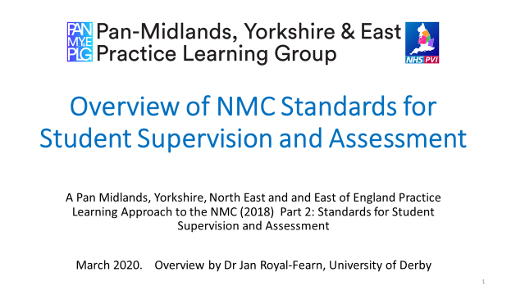

When you have listened to the podcast you might want to read through the NMC SSSA standards and they are linked below.

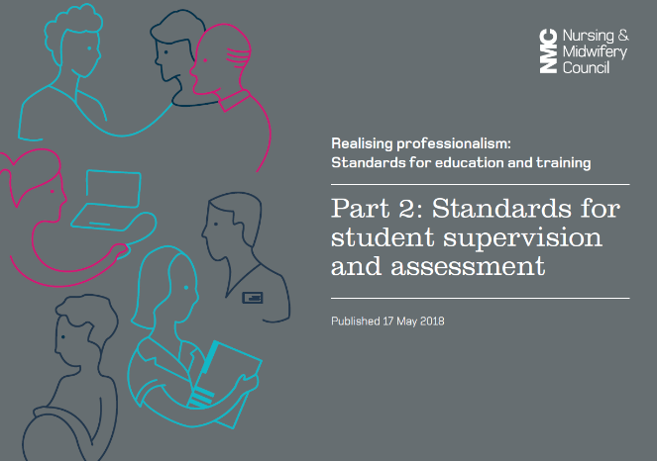 NMC SSSA link

Now take a few moments to consider the impact this will have on your workplace and how you will support student learning as a supervisor. When you are ready, move onto activity 2.

Activity 2:
2.1: Facilitating Learning. Part of your new role as a practice supervisor will be to support and facilitate learning for your students. In order to do this you need to consider the key elements of the placement process and how you can ensure your learners can maximise their opportunities for learning whilst on placement with you. Please listen to the podcast below on facilitating learning for more information on this. It is 27 minutes long, so get comfortable before you start. Please note all functions of the Panopto software may not show to you as described, dependant on the device you use for access.
Facilitating Learning 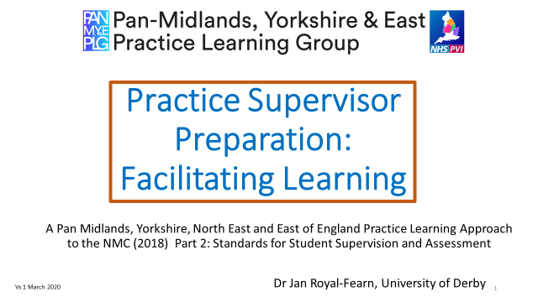

Now take a few moments to consider how you will apply this knowledge to your developing role as a practice supervisor and if possible discuss with colleagues in your organisation who may be supervisors and assessors. How do they effectively facilitate learning for their students?
2.2: Coaching: There are some good resources online from the RCN too. They explore a model where staff use a coaching approach which is student centred, empowering them to take responsibility for their own learning.
Learn more about this approach and practice supervision here

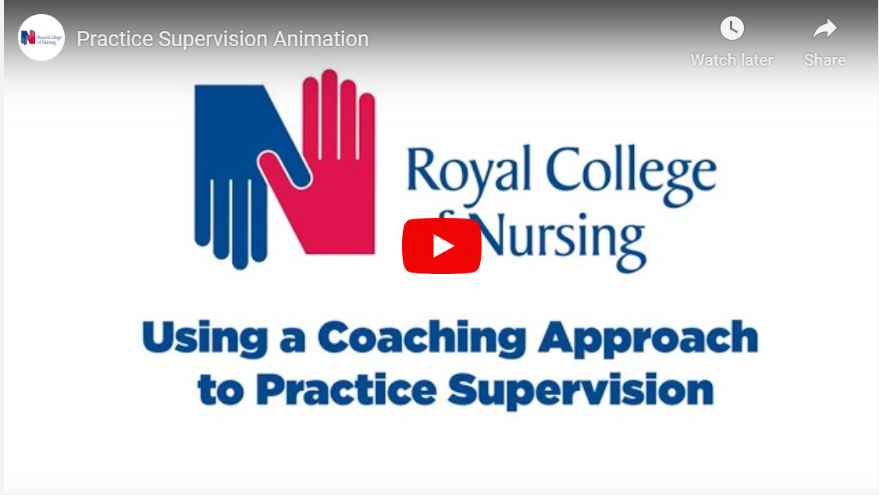 RCN Practice Supervisor Resources

You may also like to review the other resources available on this site. Then, when you are ready, move onto activity 3.

2.3: The Grow model. Another video exploring goal setting using a ‘GROW’ model can be found here and this can be a useful structure if you want to get the students to take more responsibility and identify a key learning goal for each day/ each shift. There is more information about this approach here, where the student is your ‘client’ as referred to in the video.

The GROW Model

When you have watched this, consider how you can apply this to students in your workplace and how you could structure conversations to establish goals and support them to achieve this. This enables a more collaborative approach to learning for everyone.

Activity 3:
When supervising a range of students you will need to be aware of their individual learning needs. This may be the way they each like to learn, sometimes referred to as their learning preference and it may be that some students have additional learning needs. Read through the slides below to consider the issues you may encounter with some students and how you should provide equity in your support for a diverse range of students who may have additional needs.
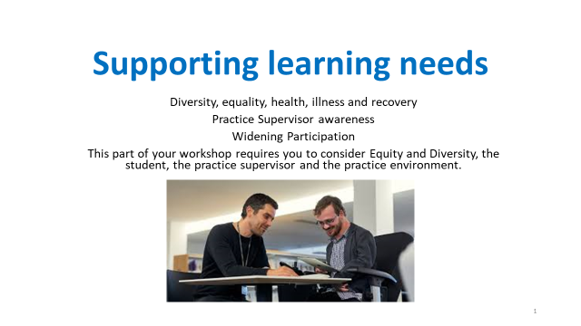
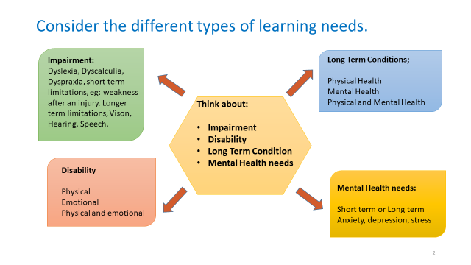

Take some time to read the RCN case studies, click on the links below.
Case study 1

Case study 2

Reflect on;
- Please think about yourself as a learner, what are you feeling or thinking when asked whether you have a disability? If you do, would you be happy to disclose this?

- Now think about the role you will have as a practice supervisor, what you may be feeling or thinking when asking a student, you are supporting, whether they may have a disability?

- As a practice supervisor, what would be your role and responsibility to a student (who has declared a disability) in terms of patient care delivery, patient safety, working within your organisation and to the standards of the Code (NMC, 2018)?

- Would you know when to seek assistance in supporting a student with a disability and whom to refer to?

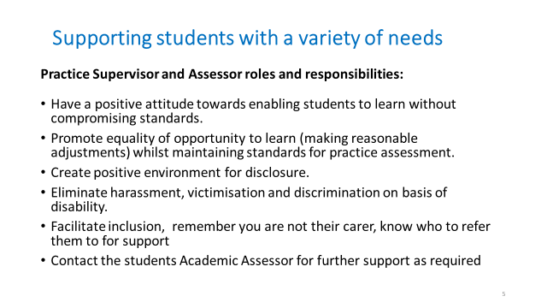

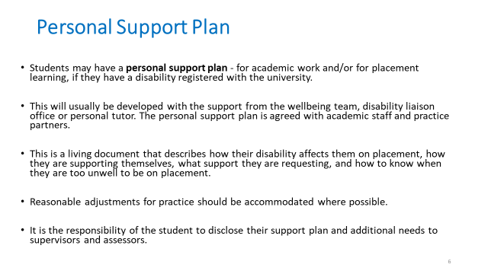

For further information and support;
- Contact the student’s Academic Assessor
- Contact the university disability support services.
- Access your local university website.
_____________________________

Activity 4:

The Midlands, Yorkshire, North East and East Practice Assessment Document (MYE PAD) has been developed by the Pan London Practice Learning Group in collaboration with practice partners, mentors, academic staff, students and service users across London, the Midlands, Yorkshire North East and the East of England regions. To support nursing students to achieve the criteria set out in the Future Nurse: Standards of proficiency for registered nurses, (NMC 2018). We started using this MYE PAD in September 2019 across some of our universities and it will be in use in all universities from September 2020. Some Universities have a paper based MYE PAD and some are using an electronic PAD.
This presentation introduces the MYE PAD as a paper based document.
For University of York students please click on the link to open the PebblePad demonstration.
https://bit.ly/37fFGTv
There are videos within this link to explain the use of the e-portfolio.
Please listen to this podcast and make notes as required. You can pause and rewind the podcast whilst you view. It is 17 minutes long. Click on the link below:
MYE PAD Podcast 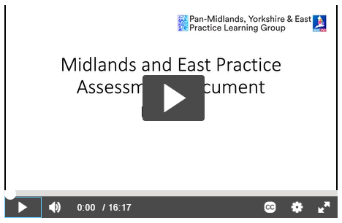

All sections of the MYE PAD are available at the PAN Midlands website as a downloadable version with a slightly different format. This would show you all the content across the whole programme if you would like to see that. It can be found at this link: www.myeplg.ac.uk
For clarity on who completes which element of the MYE PAD others have found this summary most helpful.
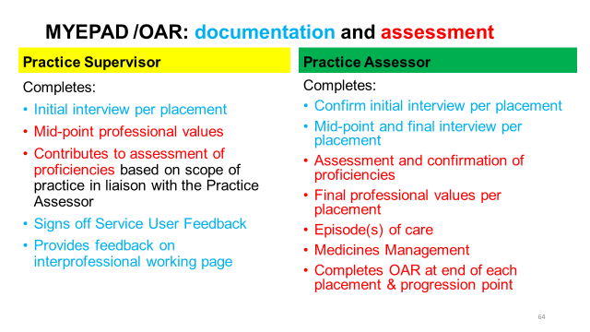

Activity 5:
In 2018 the NMC also made changes to the standards pre-registration nurses needed to achieve. This is called the Future Nurse curriculum. Each university that delivers
pre-registration nursing programmes have been busy redeveloping their curriculum. Many universities launched the new future Nurse Curriculum in September 2019 and some will start in September 2020.
At the University of York we commenced our new programme in September 2020 for Nursing. Please follow the link below to view our Nursing course plan:
https://www.york.ac.uk/media/healthsciences/documents/student-intranet/course-plans/SEPT19Plan.pdf
The midwifery curriculum is under development. However, midwifery students will be supported in practice under the NMC SSSA (2018). Updates about the Midwifery Programme can be found on our Health Sciences webpages as they occur.

If you want to know more about the specific standards for your learners please see the links below
New NMC Standards for pre-registration nurses (if you host nursing students)
https://www.nmc.org.uk/standards/standards-for-nurses/standards-of-proficiency-for-registered-nurses/
NMC Standards for Nurse Associates (if you host trainee nurse associates)
https://www.nmc.org.uk/standards/standards-for-nursing-associates/

This is the end of the online learning content.

Activity 6: Work Based Learning
After completing this learning, we now move onto the activities we would like you to complete in your workplace, as evidence of your learning and completion of this preparation for the practice supervisor role. Completion of the quiz will provide a certificate to confirm achievement. The quiz MUST be completed to show understanding of the new role. Completion of the quiz will provide you with a certificate to confirm your achievement.

The below activity is a requirement of some Trusts/ Organisations, please check with your Practice Education Teams if you are unsure. All Practice Supervisors will be required to complete this activity before becoming a Practice Assessor. The following learning activity will assist your learning and understanding of the Practice Supervisor role.
As someone who is new to supervising students we would like you to complete an Episode of Care whilst teaching a learner. This is the same format final year students will complete in their programme and will give you an insight into what they need to achieve in their assessment too. The learner you supervise doesn’t have to be a student, but can be any learner in your team. Anyone who needs to learn something that you know and can help them with.
The teaching only needs to be 10 minutes approximately. Whilst at work we would like you to complete the Episode of Care document below and have it assessed by a colleague in practice who has experience of assessment – this may be a mentor / practice assessor or educator.
Using the framework of the episode of care on the following pages:
- Consider how you will facilitate learning in practice as a novice practice supervisor.
- Seek out an opportunity in practice to supervise and teach a junior learner/colleague in practice.
- Think about your environment / workplace and the learning opportunities there are.
- Plan what you are going to deliver.
- Consider the skills and resources needed to teach any clinical skills.
- Practice giving feedback to the learner afterwards.
- Reflect on the experience, what went well? What would you do differently?
- Provide a written reflection on this experience, using the episode of care format.
- Have this assessed by a practice assessor, through their observation of your teaching and discussion, or by discussion only with them, if they were unable to observe you.
- Return the assessor page only to your register holder (see detail below)
- Complete the certificate and reflective account too and return to your register holder. (Don’t forget to use this for your NMC revalidation too if relevant)

Summary and further learning:
We hope you have enjoyed this learning package.
Please complete the quiz to assess your knowledge as evidence you have completed this workbook resource. For Private, Independent and Voluntary Organisations please send confirmation of your achievement to dohs-pll@york.ac.uk.
NHS employees are required to send their certificate and Episode of Care activity to the Trust Practice Education Teams. The completion of both elements will be mandatory for some areas. You will need to send your certificate and Episode of Care to your employers Practice Education Team to register your qualification.

Take the quiz: https://forms.gle/99vAYVG7k8Sfz3tH6

Preparation for the practice supervisor role.
Part 3 Episode of Care 1

(Taken from the Practice Assessment Document Part 3 (MYE PAD)
This assessment should be undertaken and assessed by a Practice Assessor / Mentor/ Educator when completed.

Guidelines
The participant will be given the opportunity to supervise and teach a junior learner/colleague in practice and provide a written reflection on this experience. This needs to be based on the delivery of direct person-centred care. Professionalism underpins all aspects of the participant’s performance.

The aim of this assessment is to demonstrate the participants achievement against the following five platforms within the Future Nurse: Standards of proficiency (NMC 2018) in the context of their field(s) of practice:

- Assessing needs and planning care
- Providing and evaluating care
- Improving safety and quality of care
- Leading nursing care and working in team
- Coordinating care

Effective communication and relationship management skills underpin all aspects of care. (Annex A)
Participants are required to use appropriate approaches and techniques considering the person’s motivation, capacity and need for reasonable adjustment applying understanding of mental capacity and health legislation as appropriate.

Learning outcomes
The participant is able to:
- Supervise and teach less experienced students and colleagues, appraising the quality of the nursing care they provide, documenting performance, promoting reflection and providing constructive feedback to the junior learner colleague and to their practice assessor.
- Demonstrate an understanding of the factors that both facilitate and impede learning in practice.
- Demonstrate leadership in the assessment, planning, implementation and evaluation of care.
- Apply the appropriate knowledge and skills in appraising the quality of the nursing care provided by the learner colleague.
- Demonstrate effective verbal, non-verbal communication and interpersonal skills in engaging with the learner and others involved in the care and act as a positive role model.
6. Critically reflect on their own role and the role of the nurse in the supervision, facilitation and evaluation of learning for the whole team.

Your Name Workplace

Your Reflection on an episode of care
Within your reflection, describe the episode of care and how you planned and supervised the junior learner/colleague in practice who delivered person-centred care.  What did you do well? | What would you have done differently?  What learning from this episode of care will support your professional  Development going forward in your teaching and learning role?

On Completion, this page needs to be sent, along with a copy of the certificate and reflective account to your NHS Trust Practice Education Team
For Private, Voluntary and Independent placements please scan the documents and email to dohs-pll@york.ac.uk
Assessment Date:_______________________________ Your Name: _______________________________ Signature_______________________________

Practice Assessor Name:_____________________________ Signature:______________________________Workplace:_____________________________

Practice Assessor feedback
Based on the Participants reflection, your observation and discussion of this episode of care, please assess and comment on the following:
YES = Achieved No = Not Achieved
Proficiencies | Yes/No | Comments
Assessing, planning, providing and evaluating care
Chooses an appropriate care activity for the junior learner/peer to engage in and considers the learner’s needs and their current level of knowledge and skills.
Leading nursing care and working in teams Effectively prepares the junior learner/peer and provides them with clear instructions and explanations about the care activity they are to engage in.

Improving safety and quality of care
The participant undertakes a risk assessment to ensure that the person(s) receiving care is not at risk from the learner/care activity. Continuous supervision and support is provided to the junior learner/peer throughout the care activity.

Coordinating care:
Effectively communicates throughout the care activity, evaluates the care given and provides the junior learner / peer with constructive verbal and written feedback.

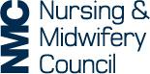
Use this form to record a written reflective account of your workshop learning and the new roles in practice and how this relates to the Code. Please make sure you do not include any information that might identify anyone.
Reflective account:
What was the nature of the CPD activity and/or practice-related feedback and/or event or experience in your practice?
What did you learn from the CPD activity and/or feedback and/or event or experience in your practice?
How did you change or improve your practice as a result?
How is this relevant to the Code?
Select one or more themes: Prioritise people – Practise effectively – Preserve safety – Promote professionalism and trust

