Workbook for Transition - mentors to practice supervisor and practice assessor roles.

This resource was developed in March 2020 and edited locally in June 2020, to replace face to face teaching sessions in light of Coronavirus. In addition, it has been revised in October 2020 to support midwives supervising and assessing students learning in practice.
The PAN Midlands, Yorkshire, North East and East Practice Learning Group (MYNEE PLG) started in 2016 with an original core aim to develop a common practice assessment document (PAD). Since inception, it has now grown to represent 32 universities across the Midlands, Yorkshire, East of England and more recently North East of England, hence the name change to MYENEEPLG. We collaborate to provide practice learning resources and support across all our member universities and work with other regional groups too.
This workbook is aimed at existing mentors who need to transition into the new roles of practice supervisor and practice assessor, in line with the NMC Standards for Student Supervision and Assessment (NMC 2018, (SSSA)). These new standards set out the NMC expectations for the learning, support and supervision of students in placements. These standards replace the 2008 mentor standards and change the role of mentoring significantly.
The podcasts and activities in this workbook are designed for you to use at your own pace and so you can move faster through elements you already know about, spending more time on the ones that are new for you. That means the amount of time you take will be variable, but the maximum time is about 3 hours.
There is a quiz to complete afterwards which must be completed to confirm achievement. On successful completion of this you will be able to print a certificate for your records. Details are at the end.
For private, voluntary and independent staff, please send this certificate to your local university on dohs-pll@york.ac.uk to register your training.
For NHS staff please email your employer Practice Education Team.

We hope you find this resource interesting and useful.
Any queries or feedback, please email dohs-pll@york.ac.uk

Activity 1:
Listen to the podcast below for an overview of the NMC SSSA standards and how they will impact on you as an existing mentor. This podcast is 27 minutes long so you might want to sit comfortably and get a coffee, before pressing start. You may want to make some notes as you listen to the presentation. Please note all functions of the Panopto software may not show to you as described on the podcast, depending on the device you use for access. Although this podcast was recorded with a nursing programme focus the principles of the SSSA are applicable to all NMC registrants.

SSSA overview podcast 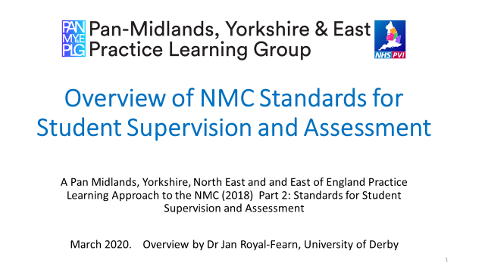

When you have listened to the podcast you might want to read through the NMC SSSA standards and they are linked below.

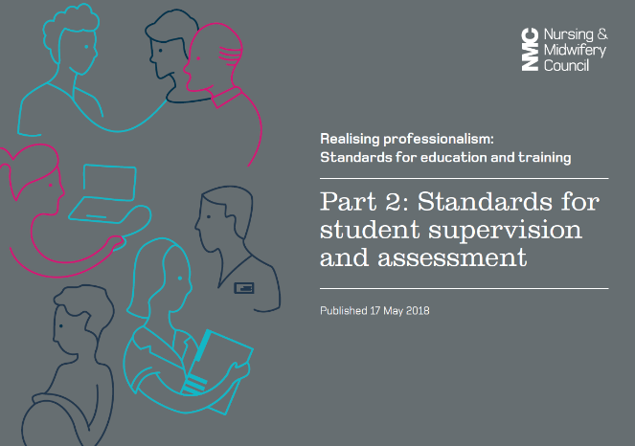 NMC SSSA link

Now take a few moments to consider the impact this will have on your workplace and when you are ready, move onto activity 2.
Activity 2:
When supporting a range of students you will need to be aware of their individual learning needs. This may be the way they each like to learn, sometimes referred to as their learning preference and it may be that some students have additional learning needs. Read through the slides below to consider the issues you may encounter with some students and how you should provide equity in your support for a diverse range of students who may have additional needs.
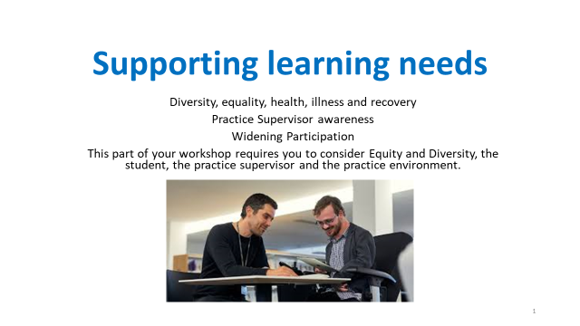
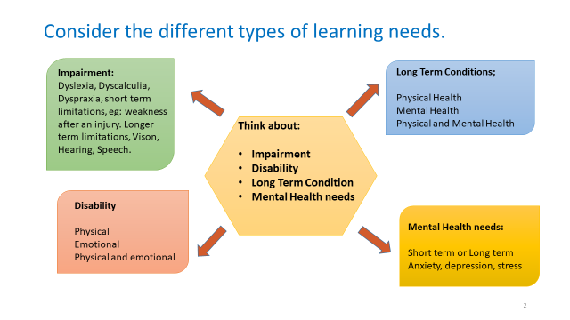

Take some time to read the RCN case studies, click on the links below.
Case study 1

Case study 2

Reflect on;
- Please think about yourself as a learner, what are you feeling or thinking when asked whether you have a disability? Would you be happy to disclose this?

- Now think about the role you will have as a practice supervisor, what you may be feeling or thinking when asking a student, you are supporting, whether they may have a disability?

- As a practice supervisor, what would be your role and responsibility to a student (who has declared a disability) in terms of patient care delivery, patient safety, working within your organisation and to the standards of the Code (NMC, 2018)?

- Would you know when to seek assistance in supporting a student with a disability and whom to refer to?

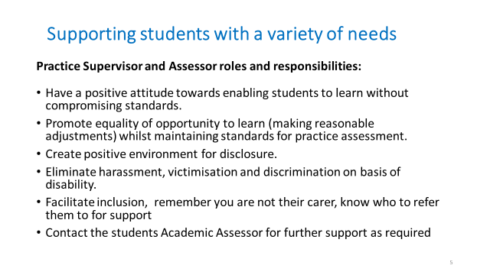

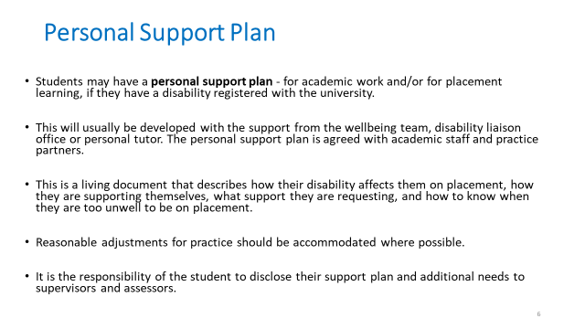

For further information and support;
- Contact the student’s Academic Assessor
- Contact the university disability support services.
- Access your local university website.
_____________________________
Activity 3:
Practice Supervisor Feedback
Practice Supervisors contribute to the student’s record of achievement by periodically recording relevant observations on the conduct, proficiency and achievement of the students they are supervising (NMC, 2018). Practice Supervisors serve as role models for safe and effective practice in line with their code of conduct. They support learning in line with their scope of practice to enable students to meet their proficiencies and programme outcomes. Practice Supervisors support and supervise students, providing feedback on their progress towards, and achievement of, proficiencies and skills (NMC, 2018).

If you are supporting a student midwife as a Practice Supervisor, they will ask you to complete a ‘Practice Supervisor feedback’ sheet which they will share with you and when completed will be uploaded to their PebblePad.

If you are supporting a student midwife as a Practice Assessor it is essential that you use the feedback on these sheets to inform your assessment of the student’s progress and achievement of clinical competencies.

For Activity 3 please record in the boxes below suggestions of Practice Supervisor feedback on a student’s progress and action plan which you may document during the placement(s).
- Feedback on student’s conduct, proficiency and achievements (where possible please state any particular competencies by number where you can give specific feedback –your student can show you these on PebblePad)

- Action plan-if required

Practice Supervisors will not be required to input into a midwifery students’ PebblePad.
If you are supporting a student as a Practice Assessor you will already be familiar with the documentation required in PebblePad.
For University of York students please click on the link to open the PebblePad demonstration.
https://bit.ly/37fFGTv
Activity 4:

In 2019, the NMC made changes to the standards that pre-registration midwifery students need to achieve. This is called the Future Midwife curriculum. Each university that delivers
pre-registration midwifery programmes are busy redeveloping their curriculum. Some universities will launch the new Future Midwife Curriculum in September 2020 however, all programmes must adhere to these standards by September 2022.

For Activity 4, access and read the new Future Midwife standards via the link below:
https://www.nmc.org.uk/globalassets/sitedocuments/standards/standards-of-proficiency-for-midwives.pdf

- Reflect on the opportunities and challenges of implementing the new Future Midwife standards within current maternity service.

- Consider how these standards may impact on your role as either a Practice Supervisor or a Practice Assessor.

Summary:
Please complete the quiz to assess your knowledge as evidence you have completed this workbook resource.
Take the quiz https://forms.gle/1urKomh2RuyehHVk9
Please email a copy of your certificate of completion as evidence for the Practice Assessor register to your employer Practice Education Teams. For Private, Independent and Voluntary Organisations, please email your certificate to dohs-pll@york.ac.uk.
This is the end of the content. At this point please use the certificate of completion to add to your training records and then write a short reflection using the NMC template on the following page.

Use this form to record a written reflective account of your workshop learning and the new roles in practice and how this relates to the Code. Please make sure you do not include any information that might identify anyone.
Reflective account:
What was the nature of the CPD activity and/or practice-related feedback and/or event or experience in your practice?
What did you learn from the CPD activity and/or feedback and/or event or experience in your practice?
How did you change or improve your practice as a result?
How is this relevant to the Code?
Select one or more themes: Prioritise people – Practise effectively – Preserve safety – Promote professionalism and trust

