Cost-Accuracy Analysis of Chronic Obstructive Pulmonary Disease Screening in Low- and Middle-Income Countries

SUPPLEMENTAL METHOD to a Research Letter published in the American Journal of Respiratory and Critical Care Medicine

Sakshi Mohan (1), Maria Kathia Cárdenas (2), Federico Ricciardi (3), Trishul Siddharthan (4), Suzanne L Pollard (5,6), Natalie A Rykiel (5,6), William Checkley (5,6), John R Hurst (7)*†, Marta O Soares (1)* for the GECo Study Investigators.

*: joint Senior Author, †: corresponding Author.

The GECo Study Investigators: Patricia Alupo, Julie A Barber, Maria Kathia Cárdenas, Ram K Chandyo, William Checkley, Santa Kumar Das, Oscar Flores-Flores, John R Hurst, Bruce Kirenga, J Jaime Miranda, Sakshi Mohan, Suzanne L Pollard, Shumonta A Quaderi, Federico Ricciardi, Natalie A Rykiel, Arun K Sharma, Laxman Shrestha, Trishul Siddharthan, Marta O Soares, Adaeze C Wosu

1. Centre for Health Economics, University of York, York, UK
2. CRONICAS Centre of Excellence in Chronic Diseases, Universidad Peruana Cayetano Heredia, Lima, Peru
3. Department of Statistical Science, University College London, London, UK
4. Division of Pulmonary and Critical Care, Miller School of Medicine, University of Miami, Miami, Florida, USA
5. Division of Pulmonary and Critical Care, School of Medicine, Johns Hopkins University, Baltimore, USA
6. Center for Global Non-Communicable Disease Research and Training, School of Medicine, Johns Hopkins University, Baltimore, USA
7. UCL Respiratory, University College London, London, UK

This supplement describes the assumptions applied for cost-accuracy analysis of three COPD screening tools (Case finding questionnaires, CFQ) - CAPTURE (COPD Assessment in Primary Care To Identify Undiagnosed Respiratory Disease and Exacerbation Risk, which includes peak expiratory flow, PEF), COLA-6 (COPD in LMICs Assessment-6, which includes PEF) and the Lung Function Questionnaire (LFQ, which does not include PEF).

To characterise the screening and diagnosis pathway, we developed a decision model that considered the likelihood of reaching individuals for the screening visit, prevalence of COPD, accuracy of the screening questionnaire, and likelihood of individuals accessing the health system for a spirometry-confirmed diagnosis upon identification as a presumptive case. Each step of the pathway was costed from a health system perspective, including the time for screening, the cost of tests where required (PEF and spirometry), and the cost of a clinician visit for those testing positive who access the health system.

- Decision model

The model is a static decision tree and is shown in Figure 1. The tree begins with a stochastic node reflecting the true disease status of the study participant, i.e. whether the participant has COPD (COPD +ve) or not (COPD-ve), with the probability of having COPD (“a”) based on the spirometry results of GECo1. The second stochastic node reflects the probability of reaching individuals for administration of the CFQ and uses the proportion of eligible participants that accepted to participate in GECo1 (“b”). The next stochastic node identifies the results of the application of the case-finding questionnaire, CFQ (CFQ +ve or CFQ -ve) based on the specificity and sensitivity of the CFQ as observed in GECo1. In particular, the sensitivity (“c”) of CFQ reflects the proportion of COPD +ve cases who are CFQ+ve and the specificity (“d”), the proportion of COPD -ve cases who are CFQ-ve . Following the identification of COPD suspects based on the questionnaire, CFQ +ve participants are assumed to be referred to a health facility for a confirmatory spirometry test. Only a proportion (“e”) is assumed to follow-through; this proportion is assumed to be the same for both COPD +ve and COPD – ve cases. Among the participants that follow-through to receive a confirmatory test, only a proportion (“f”) will finally receive a spirometry test, based on the availability of spirometry in their respective study site. Those CFQ +ve cases who follow through and receive the correct diagnosis with spirometry will then be given a confirmed diagnosis, i.e. correctly classified COPD +ve cases will receive a confirmed positive diagnosis and misclassified COPD -ve cases will be correctly diagnosed as negative.

Table 1 provides the values of probabilities applied to the decision tree.

Figure 1. Decision tree for screening using a case-finding questionnaire (CFQ), assuming that confirmatory diagnosis using spirometry takes place in-facility.
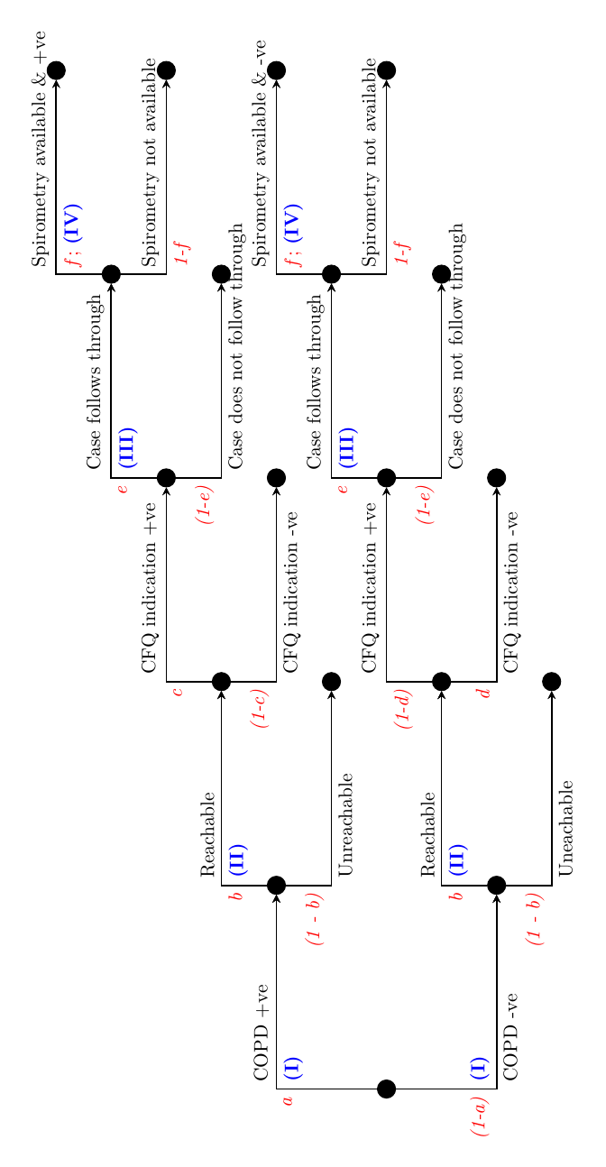

Table 1. Probabilities for the nodes in the decision tree

Cost question | Code | Nepal | Uganda | Peru
Prevalence of COPD | a | 18.2% | 7.4% | 2.7%
Proportion reachable | b | 62.8% | 84.5% | 58.4%
Sensitivity (LFQ) | c | 58.8% (95.7%*) | 58.8% (90.4%*) | 58.8% (92.6%*)
Sensitivity (CAPTURE+PEF) |  | 60.0% | 60.% | 60.%
Sensitivity (COLA-6) |  | 45.6% (98.4%*) | 45.6% (96.5%*) | 45.6% (97.9%*)
Specificity (LFQ) | d | 78.9% (27.5%*) | 78.9% (25.2%*) | 78.9% (30.4%*)
Specificity (CAPTURE+PEF) |  | 81.5% | 81.5% | 81.5%
Specificity (COLA-6) |  | 86.6% (11.6%*) | 86.6% (10.7%*) | 86.6% (12.4%*)
% following through to confirmatory spirometry | e | 65.0% | 65.0% | 65.0%
% receiving confirmatory spirometry | f | 38.0%  (Chokhani et al. 2020) | 24.4%  (Kibirige et al. 2017) | 34.0%  (Tálamo et al. 2007)
* For sensitivity analysis
- Costing assumptions

Table 2 list the various health system costs assumptions used to estimate the cost of implementing the COPD screening tools in the three study sites.

Table 2. Costing assumptions
Cost component | Code | Nepal | Uganda | Peru
Travel time for CHW to reach individual, per visit | t_{travel} | 21.6 minutes | 20 minutes | 32.5 minutes
Cost of transportation per visit, per visit | g | 0.27 | 0.57 | 6
Other travel expenses, per visit | h | 0.86 | 0.27 | 0.00
Average monthly remuneration of CHW | ⍵_{chw} | 93.2¹ | 88  (Hamainza et al. 2014) | 278.7²
Duration (LFQ) | t_{cfq} | 6.37 minutes
Duration (CAPTURE+PEF) |  | 7.58 minutes
Duration (COLA-6) |  | 9.13 minutes
Cost of materials required for CFQ, per visit | j | 0 | 0 | 0
Cost of PEF test | l | 0.13 | 0.13 | 0.13
Average cost of a health centre visit | n | 1.25³ | 1.55³ | 10.37³
Unit cost of a spirometry test | o | 4.88 (B.P. Koirala Institute of Health Sciences 2019) | 36.75  (Kibirige et al. 2017) | 18.28  (Ministerio de Salud 2018)
All costs are presented in 2019 $
¹ based on the study
² based on the minimum wage in Peru
³ (Stenberg et al. 2018)
Table 3 provides a detailed breakdown of the cost per single diagnostic workup of administering the three COPD screening tools based on the cost assumptions presented in Table 2.

Table 3. Breakdown of costs of LFQ, CAPTURE+PEF, and COLA-6+PEF (2019 USD)

 |  |  | Cost per participant (LFQ) |  |  | Cost per participant (CAPTURE+PEF) |  |  | Cost per participant (COLA-6+PEF)
 |  | Formula (refer to Table 2) | Nepal | Uganda | Peru | Nepal | Uganda | Peru | Nepal | Uganda | Peru
I | Cost of reaching an individual (per visit) | ⍵_{chw}/(working hours per day * working days per month) * 2*t_{travel}/60 + g + h | 1.53 | 1.19 | 7.79 | 1.53 | 1.19 | 7.79 | 1.53 | 1.19 | 7.79
II | Cost of administering the case-finding questionnaire | ⍵_{chw}/(working hours per day * working days per month) * t_{cfq}/60 + j + l | 0.06 | 0.06 | 0.18 | 0.20 | 0.20 | 0.34 | 0.21 | 0.21 | 0.38
III | Cost of a confirmatory diagnosis - GP consultation | n | 1.25 | 1.55 | 10.37 | 1.25 | 1.55 | 10.37 | 1.25 | 1.55 | 10.37
IV | Cost of a confirmatory diagnosis - spirometry | o | 4.88 | 36.75 | 18.28 | 4.88 | 36.75 | 18.28 | 4.88 | 36.75 | 18.28
Note: We assume 8 working hours per day and 21 working days per month.

References

B.P. Koirala Institute of Health Sciences. 2019. Tariff List. Dharan.
Chokhani, Ramesh et al. 2020. “Knowledge, Practice Pattern and Attitude toward Asthma Management amongst Physicians from Nepal, Malaysia, Lebanon, Myanmar and Morocco.” Journal of Asthma. https://www.tandfonline.com/doi/abs/10.1080/02770903.2020.1742351 (July 3, 2020).
Hamainza, Busiku et al. 2014. “Monitoring, Characterization and Control of Chronic, Symptomatic Malaria Infections in Rural Zambia through Monthly Household Visits by Paid Community Health Workers.” Malaria Journal 13(1). https://pubmed.ncbi.nlm.nih.gov/24678631/ (July 1, 2020).
Kibirige, Davis et al. 2017. “Access to Affordable Medicines and Diagnostic Tests for Asthma and COPD in Sub Saharan Africa: The Ugandan Perspective.” BMC pulmonary medicine 17(1): 179. https://link.springer.com/articles/10.1186/s12890-017-0527-y (June 26, 2020).
Ministerio de Salud. 2018. Tarifario 2018 (Hospital Cayetano Heredia). Lima.
Stenberg, Karin et al. 2018. “Econometric Estimation of WHO-CHOICE Country-Specific Costs for Inpatient and Outpatient Health Service Delivery.” Cost Effectiveness and Resource Allocation 16(1): 11. https://resource-allocation.biomedcentral.com/articles/10.1186/s12962-018-0095-x (July 7, 2020).
Tálamo, Carlos et al. 2007. “Diagnostic Labeling of COPD in Five Latin American Cities*.” Chest 131(1). http://www.platino-alat.org (October 28, 2020).

