Development & Assessment Centres (DACs)
Application Form Guidance Notes

The guidance notes and supporting web pages have been created to provide additional information and guidance. However if you, your line manager or Head of Department have any concerns or questions regarding this process please contact Professional@york.ac.uk or the Professional@York Administration Team on either ext. 4036 or 4888.

Section 1: Personal Details:
Please complete your work related personal details in this section.
Section 2: Statements to Support Your Application
You should aim to support your application with information that describes how you have made a difference and successfully contributed to your department and the University.
Please answer the following questions:
- In your current role, how do you make a difference to your team, department or University’s performance?
- What impact do you want to have in successfully contributing to the delivery of the University Strategy in the longer term?
- What are your career aspirations for the future?
- What difference will the Development & Assessment Centres make to the success of your career and your contribution to the University of York?
Section 3 – Current Leadership Capability
As the Development and Assessment Centres are not looking to recruit to a particular role but rather to highlight current and potential leadership capability, the University of York Leadership Principles provides the ideal framework against which to assess individuals. Full details of the University of York Leadership Principles can be found at www.york.ac.uk/admin/hr/professional@york.

We have used our Leadership Principles as the framework for the application form and invite you to share specific examples where you can illustrate you have applied these principles in your current or a previous role. If you are not currently in a formal leadership role, the principles we are asking you to evidence can also be demonstrated by individuals who show personal leadership and you should consider them in this light.
You can draw from any examples or combination of examples that enable you to describe your experience and evidence your application of these principles to any appropriate situation. Please be specific with the examples and the actions you took.

A useful format for present this is:
- State the context in which you demonstrate this principle (Situation or Task),
- Followed by what you did (Action),
- And what the outcome was (Result).
Be as clear as you can in your description, so that those reading your application can relate to the situation and understand directly the impact of your choices and approach.
Section 4 – Experience Based Questions.
Recognising that the experience of those applying will vary considerably, this section of the form provides information that will illustrate the diversity of experience of those applying. This will help us in planning future Learning and Development activities as well as highlighting experience that you may be able to contribute to the institution. It will also highlight if further experience in certain areas would be beneficial.

For those individuals who secure a place on a Development and Assessment Centre questions 4a and 4b will be used to benchmark your performance against other individuals who have participated in IBM Assessment Centres and who have worked with similar size teams and with similar management experience.
Section 5 – Employment History
If you have an up to date CV, please just attach this to your application. Alternatively please provide a brief history of your employment to date.
Section 6 – Development and Assessment Centre Dates and Availability
Should you be successful in your application you will be assigned to a Development and Assessment Centre. In order to ensure we can meet the aspirations of those who are short-listed you are asked to identify which of the three Development and Assessment Centres you are able to attend. If you are able to attend all of them, you are also asked to indicate your preference order. Whilst this cannot be guaranteed, it will be taken into consideration when allocating successful candidates to a Centre.
Section 7 – Criteria (ticked by Line Manager)
These criteria have been identified as being mandatory for all individuals wanting to apply. Your Line Manager is asked to confirm that you meet this criteria and then confirm they support your application.
Section 8 - Supporting Statement from your Line Manager or Head of Department
Your immediate Line Manager or Head of Department can complete this section of your application. We advise you to discuss this with your line manager and agree with them who will be responsible for completing this statement.

This statement should be no more than 500 words and provide specific examples of the contribution you have made to the Department in terms of your impact on people, processes and strategy.

This statement will be considered as part of the selection process. As a result, please ensure you submit your application to the agreed person in plenty of time.

Both your Line Manager and Head of Department are responsible for supporting your application for the Development & Assessment Centres and must sign off your completed application.

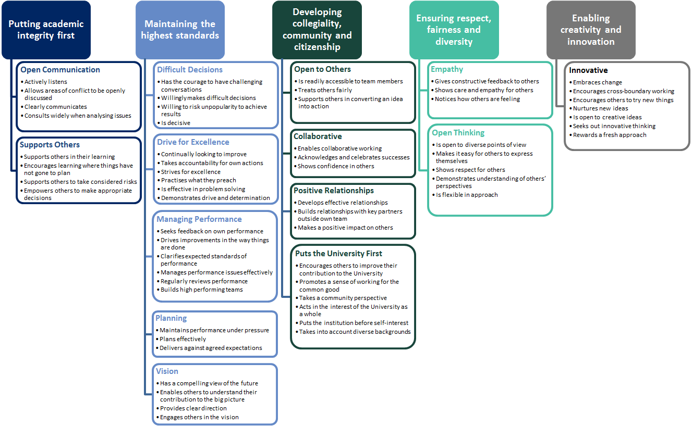
Leadership Principles
Development & Assessment Centres
Application Form

This section to be completed by applicant:
- Personal Details:
Name:
Employee Number:
Department:
Job Title:
Ext. No:
Time in Role:
Line Manager:
HoD Name:

- Statement to Support Your Application Please answer the following questions:
(No more than 250 words per question)

- In your current role, how do you make a difference to your team, department or University’s performance?

- What impact do you want to have in successfully contributing to the delivery of the University Strategy in the longer term?

- What are your career aspirations for the future?

- What difference will the Development & Assessment Centres make to the success of your career and your contribution to the University of York?

- Current Leadership Capability - University of York Leadership Principles:
In no more than 1000 words, please identify a maximum of 3 situations where you have demonstrated aspects of the leadership principle ‘Maintaining the Highest Standards’ . (See Guidance notes)
Leadership Principle ‘ Maintaining the Highest Standards’(A maximum 1000 words):

- Experienced Based Questions – Identified by Applicant
You are asked to choose the statement that is most like the experience you have, based on previous roles. This will not be used as part of the short-listing process.
- Indicate the highest number of direct reports you have managed (strike-through redundant answers):
I have not managed direct reports | I have managed less than 3 | I have managed 4-8 | I have managed more than 8
- Indicate the level staff you have managed (strike-through redundant answers):
I have not managed direct reports | Junior Staff | Experienced and specialist staff | Senior/Executive staff
- Indicate level of budgetary experience (strike-through redundant answers):
None | Management of expenditure budget | Management of income and expenditure over a range of activities | Management of full business/ Dept budget
- Indicate length of time in HE Sector (strike-through redundant answers):
Up to 2 years | 2-6 years | 7-10 years | 11+ years
- i) Indicate the level of involvement you have had with departmental wide projects (strike-through redundant answers):
No involvement | Member of steering group | Member of project team | Project manager
- Indicate the level of involvement you have had with University wide projects (strike-through redundant answers):
No involvement | Member of steering group | Member of project team | Project manager

5. Employment History: Please attach an up to date CV or complete your employment history below.
Employer

Job Title

Brief description of duties

Date from
Date to
Reason for leaving
Employer

Job Title

Brief description of duties

Date from
Date to
Reason for leaving
Employer

Job Title

Brief description of duties

Date from
Date to
Reason for leaving
Employer

Job Title

Brief description of duties

Date from
Date to
Reason for leaving

6. Development and Assessment Centre Dates and Availability:
There are three centre dates available for this round of applications. Please indicate your availability below
These will be: Your availability
7-8 November 2017 – The Parsonage Hotel, York YES/NO
13-14 December 2017 – The Marriott Hotel, York YES/NO
23-24 January 2017 – The Marriott Hotel, York YES/NO

6a. On-Line CAT Tests: As part of your application we will be asking you to complete an on-line test to assess your verbal reasoning. This will take place in test conditions. Please indicate which of the available time slots you would like to attend and provisionally block them in your diary:
Please select 1 date and time only.
If you have already completed the online test as part of a previous application you do not need to re-take the test.
Friday 8th September 2017 – 14:00 – D/114, Derwent | ☐
Tuesday 12th September 2017 – 10:00 – RCH/018, Ron Cooke Hub | ☐
Wednesday 13th September 2017 – 14:00 – D/114, Derwent | ☐
Thursday 14th September 2017 – 10:00 – D/114, Derwent | ☐

I acknowledge that the information provided here is accurate to the best of my knowledge.
Applicant’s Signature: |  | Date:

This section to be completed by the applicant’s immediate line manager :
7. Criteria (ticked by Line Manager):
☐ | Has been in current role for at least 12 months
☐ | Is working at the expected level in their role
☐ | Has a positive impact on the achievements of their team/section department
☐ | Exhibits collaborative working
☐ | Demonstrates a commitment to continuous improvement in all elements of their work
☐ | As their Line Manager, I support their application

As Line Manager, I also agree to:
☐ | Support my team member in attending the Development & Assessment Centre and follow up coaching sessions
☐ | Support my team member in participating in other development activities that are highlighted and agreed in their development plan
☐ | Confirm that the information provided in this application is accurate and up to date

Line Managers  Signature: |  | Date:

8. Supporting Statement from Line Manager or Head of Department
(No more than 500 words)
Please provide specific examples on the contribution the individual has made to the Department in terms of their impact on people, processes and strategy. This information will be used in the selection of candidates.

As Head of Department, I support this application
HoD’s Signature: Date:

Please return via e-mail to: Professional@york.ac.uk

What happens if my application is not successful?
Places on the development and assessment centres are limited so there is a need to select and prioritise candidates. We also want to make sure that the individuals who attend the development and assessment centre are in the best position to make the most of the opportunity it offers.
There are two points within the application process where you may not be successful:
- after taking the online test
- after shortlisting
Bear in mind that if you are not successful, you are welcome to apply again in the future.
For anyone who is not successful, or who decides that the development and assessment centre route is not for them, there are still opportunities to enhance your development.
We have a broad programme of courses that are available to all staff. https://www.york.ac.uk/admin/hr/browse/learning-and-development/courses-and-events
We also have a number of different management and leadership courses available. https://www.york.ac.uk/admin/hr/browse/learning-and-development/leadership-and-management

