Academic Development & Assessment Centres (DACs)
Application Form Guidance Notes

Please read these guidance notes carefully and follow the instructions provided when completing your form. If you or your Head of Department have any concerns or questions regarding this process, please contact leadership-development@york.ac.uk or the Leadership Development Team on ext. 4036.

Section 1: Personal details
Please complete your work related personal details in this section.

Section 2: Statements to support your application
You should aim to support your application with information that describes how you have made a difference and successfully contributed to your department and the University.
Please answer the following questions:
- In your current role, how do you make a difference to your team, department or University’s performance?
- What impact do you want to have in successfully contributing to the delivery of the University Strategy in the longer term?
- What are your career aspirations for the future?
- What difference will the Development & Assessment Centre make to the success of your career and your contribution to the University of York?

Section 3: Current leadership capability

As the Development and Assessment Centres are not looking to recruit to a particular role but rather to highlight current and potential leadership capability, the University of York Leadership Principles provide the ideal framework against which to assess individuals. Full details of the University of York Leadership Principles can be found at www.york.ac.uk/admin/hr/learning-and-development/leadership-and-management/leadership-principles/introduction/.
The Leadership Principles were co-created with individuals across the institution in 2008, and reviewed in 2015, and forms the basis of our 360° diagnostic tool. The principles allow us to understand not just what we do, but how we demonstrate particular values and behaviours. We have used our Leadership Principles as the framework for the application form and invite you to share specific examples from recent work experience where you can illustrate how you have applied these principles in your current or a previous role. If you have not had a break in work or a significant change in role, we would expect the examples to be taken from the last 2 years.
If you are not currently in a formal leadership role, the principles we are asking you to evidence can also be demonstrated by individuals who show personal leadership and you should consider them in this light.
You are asked to address 3 of the following 5 clusters, choosing one question from each:
- Collaborative
        - Please describe a specific time when you have built effective partnerships outside of your own team or department.

        - Please describe a specific time when you have improved the way in which teams or departments work together.
- Vision
  - Please describe a specific time when you have united others to achieve a long term goal for your team, department or the university.

  - Please describe a specific time when you have helped others to understand their role in the university’s success.

- Difficult Decisions
  - Please describe a specific time when you have made a tough decision to serve the best interests of your team, department or the university.

  - Please describe a specific time when you have taken ownership for making and communicating an unpopular decision.

- Creativity and Innovation
  - Please describe a specific time when you have helped others to embrace a change.

  - Please describe a specific time when you have increased innovative ways of working in your team or department.

- Open Thinking
  - Please describe a specific time when you have taken steps to understand the needs of others during a project or initiative.

  - Please describe a specific time when you have respected a range of perspectives when working with others.
A useful format for presenting this is:
- State the context in which you demonstrate this principle (Situation or Task),
- Followed by what you did (Action),
- And what the outcome was (Result).

Be as clear as you can in your description, so that those reading your application can relate to the situation and understand directly the impact of your choices and approach.

Section 4: Experience based questions

Recognising that the experience of those applying will vary considerably, this section of the form provides information that will illustrate the diversity of experience of those applying. This will help us in planning future Learning and Development activities as well as highlighting experience that you may be able to contribute to the institution. It will also highlight if further experience in certain areas would be beneficial.
For those individuals who secure a place on a Development and Assessment Centre questions 4a and 4b will be used to benchmark your performance against other individuals who have participated in Assessment Centres and who have worked with similar size teams and have similar management experience.

Section 5: Employment history

If you have an up to date CV, please just attach this to your application. Alternatively please provide a brief history of your employment to date.

Section 6: Development and Assessment Centre dates and availability

Should you be successful in your application, you will be assigned to the Development and Assessment Centre. Please ensure you are able to attend both days in full.

Section 7: Criteria (ticked by Head of Department)

These criteria have been identified as mandatory for all applicants. Your Head of Department is asked to confirm that you meet this criteria and then confirm they support your application.

Section 8: Supporting statement from your Head of Department

This statement should be no more than 500 words and provide specific examples of the contribution you have made to the Department in terms of your impact on people, processes and strategy.
This statement will be considered as part of the selection process. As a result, please ensure you submit your application to the agreed person in plenty of time.
Your Head of Department is responsible for supporting your application for the Development & Assessment Centre and must sign off your completed application.

Please return your completed application form via email to:
leadership-development@york.ac.uk

A paper version of the application form is available on request – please email leadership-development@york.ac.uk.

Leadership Principles
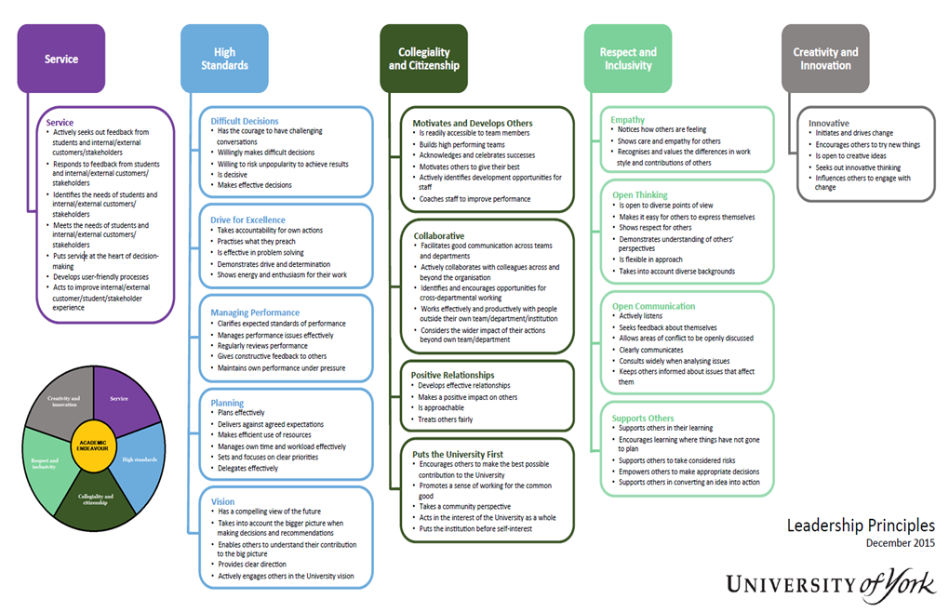

Development & Assessment Centre
Application Form

This section to be completed by applicant

- Personal Details:
Name:
Employee Number:
Department:
Job title:
Grade:
Length of time in role:
Email address:
Ext. No:
Head of Department name:
Head of Department email address:

Statement in support of your application:
Please answer the following questions (no more than 250 words per question)

In your current role, how do you make a difference to your team, department or University’s performance?
…

How was your performance rated in the last review period? (please delete as appropriate)

Objectives: Exceeded / Achieved / Partly met / Not met
Role expectations: Met / Not met

What impact do you want to have in successfully contributing to the delivery of the University Strategy in the longer term?
…

What are your career aspirations for the future?
…

What difference will the Development and Assessment Centre make to the success of your career and your contribution to the University of York?
…

Current leadership capability – University of York Leadership Principles:
In no more than 1000 words, please address 3 of the following 5 clusters, choosing one question from each:
- Collaborative
        - Please describe a specific time when you have built effective partnerships outside of your own team or department.

        - Please describe a specific time when you have improved the way in which teams or departments work together.
- Vision
  - Please describe a specific time when you have united others to achieve a long term goal for your team, department or the university.

  - Please describe a specific time when you have helped others to understand their role in the university’s success.
- Difficult Decisions
- Please describe a specific time when you have made a tough decision to serve the best interests of your team, department or the university.

- Please describe a specific time when you have taken ownership for making and communicating an unpopular decision.
- Creativity and Innovation
  - Please describe a specific time when you have helped others to embrace a change.

  - Please describe a specific time when you have increased innovative ways of working in your team or department.
- Open Thinking
  - Please describe a specific time when you have taken steps to understand the needs of others during a project or initiative.

  - Please describe a specific time when you have respected a range of perspectives when working with others.
Identify the following areas for each:
- Situation / Task
- Action
- Results
…

Experience based questions – Identified by applicant:
You are asked to choose the statement that is most like the experience you have, based on previous roles.

Indicate the highest number of direct reports you have managed (strike-through redundant answers):
I have not managed direct reports | I have managed  less than 3 | I have managed 4-8 | I have managed  more than 8

Indicate the level of staff you have managed (strike-through redundant answers):
I have not managed direct reports | Junior staff | Experienced and specialist staff | Senior/Executive staff

Indicate level of budgetary experience (strike-through redundant answers):
None | Management expenditure budget | Management of income and expenditure over a range of activities | Management of full business/Dept budget

Indicate length of time in HE Sector (strike-through redundant answers):
Up to 2 years | 2-6 years | 7-10 years | 11+ years

Indicate the level of involvement you have had with departmental wide projects (strike-through redundant answers):
No involvement | Member of steering group | Member of project team | Project manager

Indicate the level of involvement you have had with University wide projects (strike-through redundant answers):
No involvement | Member of steering group | Member of project team | Project manager

Employment history:
Please attach an up to date CV or complete your employment history below.
Employer:
Job title:
Brief description of duties:
Date from:
Date to:
Reason for leaving:

Employer:
Job title:
Brief description of duties:
Date from:
Date to:
Reason for leaving:

Employer:
Job title:
Brief description of duties:
Date from:
Date to:
Reason for leaving:

Employer:
Job title:
Brief description of duties:
Date from:
Date to:
Reason for leaving:

Development and Assessment Centre dates:
There are two centres available for this round of applications. Please indicate which centre you can attend in full, in preference order:
17 - 18 July 2019 |  | 10 - 11 September 2019

I acknowledge that the information provided here is accurate to the best of my knowledge.
Applicant’s Signature: |  | Date:

This section to be completed by applicant’s Head of Department

Criteria (ticked by Head of Department):

☐ | Has been in current role for at least 12 months
☐ | Is working at the expected level in their role
☐ | Has a positive impact on the achievements of their team/section/department
☐ | Exhibits collaborative working
☐ | Demonstrates a commitment to continuous improvement in all elements of their work
☐ | As their Head of Department, I support their application

As Head of Department, I also agree to:
☐ | Support my team member in attending the Development & Assessment Centre and follow up coaching sessions
☐ | Support my team member in participating in other development activities that are highlighted and agreed in their development plan
☐ | Confirm that the information provided in this application is accurate and up to date

HoD’s Signature: |  | Date:

Supporting statement from Head of Department:
Please provide specific examples on the contribution the individual has made to the Department in terms of their impact on people, processes and strategy. This information will be used in the selection of candidates (no more than 500 words).

…

As Head of Department, I support this application:
HoD’s Signature: |  | Date:

