Instructions

Preamble
Welcome to this experiment. These instructions are to help you to understand what you are being asked to do during the experiment and how you will be paid. The experiment is simple and gives you the chance to earn a considerable amount of money, which will be paid to you in cash after you have completed the experiment. The payment described below is in addition to a participation fee of £2.50 that you will be paid independently of your answers.

The Experiment
The experiment is interested in your preferences under risk. There are no right or wrong answers. It is in four parts. Each of the four parts consists of a series of problems. At the end of all four parts, one of the four parts will be randomly selected, then one of the problems on that part will be randomly selected, and then you will play out that problem. This will always imply playing out a lottery. The outcome of playing out this lottery will lead to a payoff to you, and we shall pay this to you in cash, plus the participation fee of £2.50, immediately after you have completed the experiment. How all this will be done will be explained below. We start by describing a generic lottery. Then we describe the four parts; you will not necessarily get them in the order that they are described here.

A Generic Lottery
We describe now what we mean by a ‘Generic Lottery’. Here we represent each lottery visually. The visual representation will be one of the following two forms.

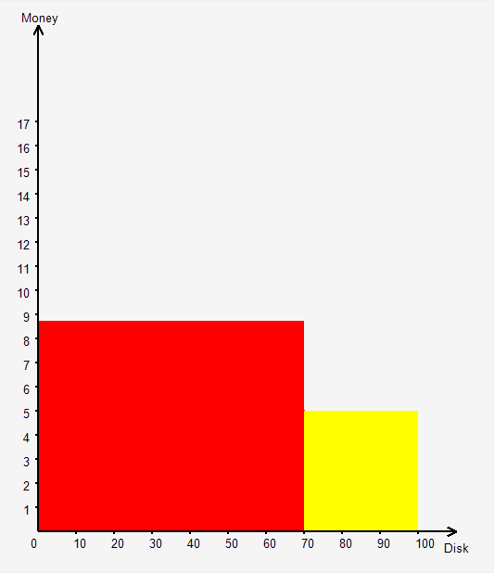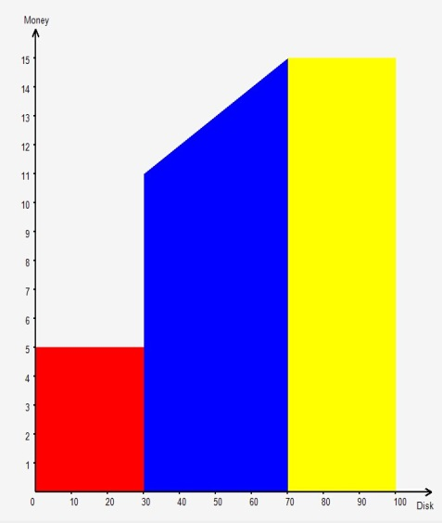

It is simplest to explain these in terms of the implications for your payment if one of these is randomly selected to be played out at the end of the experiment. What we will do in all cases is to ask you to draw ‒ without looking ‒ a disk out of a bag containing 100 disks numbered from 1 to 100. You can check that the bag contains all these disks before you do the drawing. The number on the disk that you draw will determine a point on the horizontal axis; your payment would be the amount on the vertical axis implied by that point through the figure. So, for example, in the left-hand lottery, if the number on the disk that you draw is between 1 and 70 inclusive you would get £8.75; if it is between 71 and 100 inclusive you would get £5. This implies that the chance of you getting paid £8.75 is 0.7 and the chance of you getting paid £5 is 0.3. This will also be written in words. If the right-hand lottery is to be played out, if the number on the disk that you draw is between 1 and 30 you would get £5; if it is between 31 and 70 inclusive you would get between £11 and £15 ‒ the precise amount depending upon the number on the disk drawn; if it is between 71 and 100 inclusive you would get £15.

Let us give specific examples. In the left-hand lottery, suppose the number on the disk that you draw is 80, then you would receive £5. In the right-hand lottery, suppose the number on the disk that you draw is 50, you would receive £13.

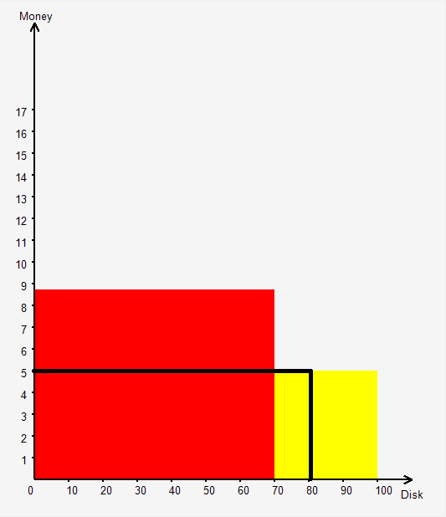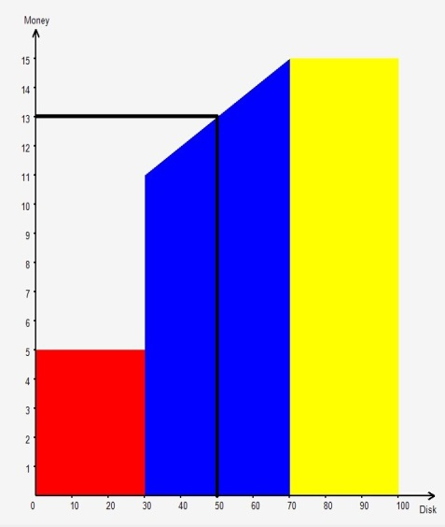
We now describe the four parts of the experiment. Remember that you might not get them in the order presented here.

Part 1: Pairwise Choices
Here each problem is a simple pairwise choice, an example of which is pictured below. In each problem you have to decide which of two lotteries you prefer. If this problem on this part is chosen for payment at the end of the experiment, then the lottery that you chose will be the one that is played out.

In the example below, the left-hand lottery is certain, and the right-hand lottery is risky; in some problems both lotteries are risky; in some lotteries one of the amounts will be £0 and thus not appear in the figure. In the figure we show the amounts of money you might win on the vertical axis and the disk number on the horizontal axis. The implications are written in words underneath the figure. So the left-hand lottery would lead to a payoff of £10 with certainty; the right-hand lottery would lead to a payoff of £15 with chance 0.4 or to a payoff of £0 with chance 0.6; you will be asked to click on the lottery that you would prefer to have played out.

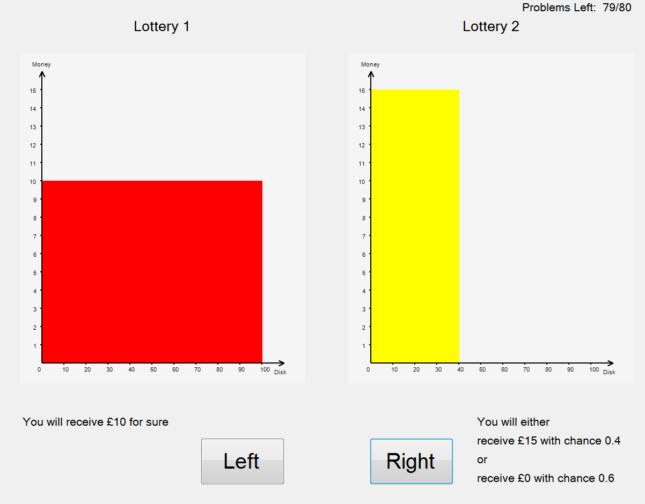

In this part you will be asked to express your preference over a total of 80 such problems. In the upper-right corner of the screen you will be told how many problems remain. In each problem, you cannot take a decision until at least five seconds have elapsed, but you can take as long as you like.

Part 2: Lists
In some ways this part is similar to Part 1, though here the pairwise choices are structured. Each problem is in the form of a list. One such list is shown in the figure below. In each list there is a set of pairwise choice problems, presented in exactly the same way as in Part 1. But, as you will, see there is a pattern: one of the two lotteries in any pair is the same throughout the list – here the left-hand lottery is always £15 with chance 0.7 and £0 with chance 0.3. The other lottery is changing through the list ‒ in the sense that the chance of getting the higher amount of money is increasing, or the amount of money is increasing.

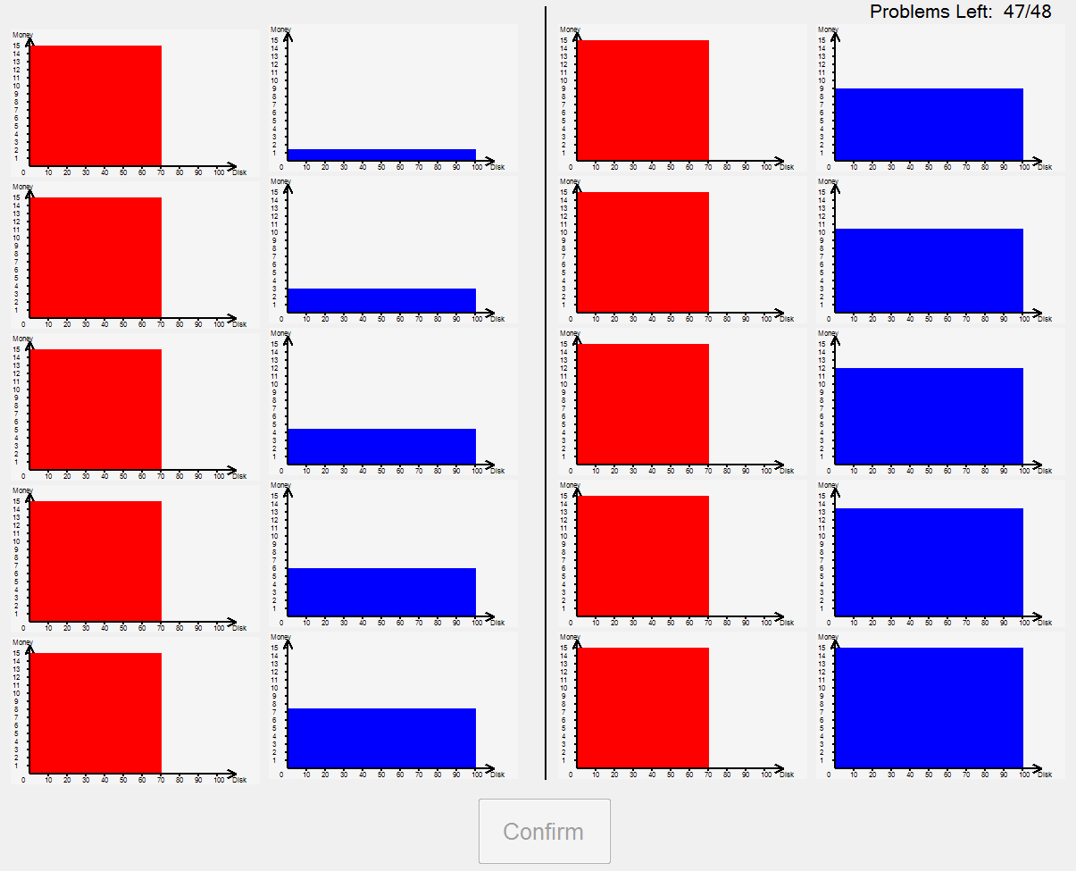

In this particular list the left-hand lottery is always the same (£15 with chance 0.7 and £0 with chance 0.3), while the right-hand lottery is a certainty with the amount of money going up from £1.50 to £15 through the list. As in Part 1, in each pair you are asked to specify which lottery you prefer. You do this by clicking on the preferred lottery; you will see that when you do this, the other lottery becomes greyed-out. However, because one of the lotteries is getting better through the list, we impose some structure on your answers. If you say that you prefer the certainty at one point, we force you to say that you also prefer the certainty further down the list. You will understand this as you click through the list. When, in each pair, one of the lotteries has been indicated as preferred by you (and the other in the pair greyed-out) the ‘Confirm’ button will become active, allowing you to record your preferences for that list and move onto to the next list.

There are a total of 48 lists in this part of the experiment. In the upper-right corner of the screen you will be told how many problems remain. In each problem, you cannot take a decision until at least five seconds have elapsed, but you can take as long as you like.

Part 3: Allocations
In each problem in this part, you will be given a quantity of tokens to allocate between two risky colours with stated chances. For each colour you will be told the exchange rate between tokens and money. An example of such a problem is shown below.

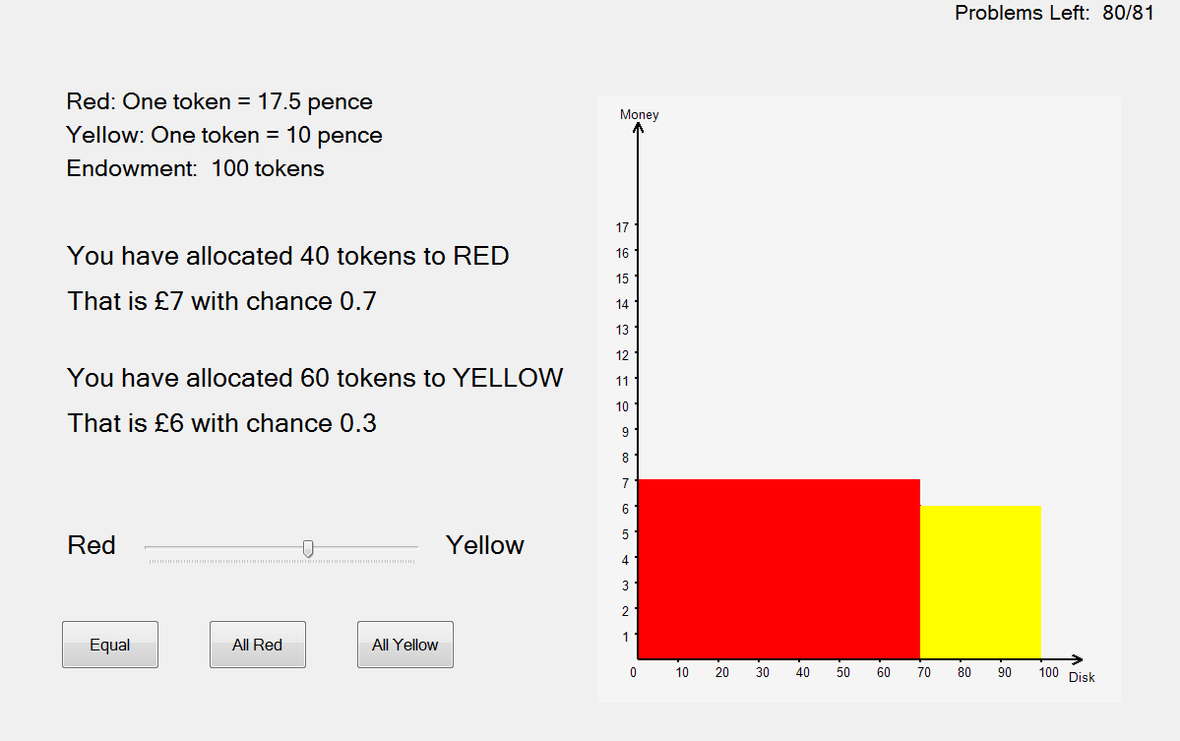

Here there are 100 tokens to allocate; the chance of red happening is 0.7 and that of yellow 0.3. You have to decide how to allocate the 100 tokens between red and yellow; shown is an example of allocation but you may prefer a different one. Your chosen allocation implies a lottery – as pictured above. If this problem were to be played out at the end of the experiment, this lottery would be played out.

There will be a total of 81 problems in this part. In the upper-right corner of the screen you will be told how many problems remain. In each problem, you cannot take a decision until at least five seconds have elapsed, but you can take as long as you like.

Part 4: Lottery Choices
In this part, in each problem you will be asked to choose a lottery. The choice set is the continuum between two ‘extreme’ lotteries illustrated in the figure below: the left-hand lottery can give any payment between £5 and £15, with all payments being equally likely; the right-hand lottery consists of a simple lottery with two possible outcomes, here £5 with chance 0.5 and £15 with chance 0.5. Your chosen lottery can be any mixture of these two ‘extreme’ lotteries. As you move the slider bar from the extreme left to the extreme right you will see the mixture lottery moves from one of the two extremes to the other. The implied payments are between £5 and £15, with the chances indicated in the figure. One such problem is shown below.

In the example below, if you accept a mixture lottery like this, you would be paid £5 with chance of 0.3, £15 with chance of 0.3, and between £11 and £15 depending on the number on the disk that you randomly draw at the end of the experiment.
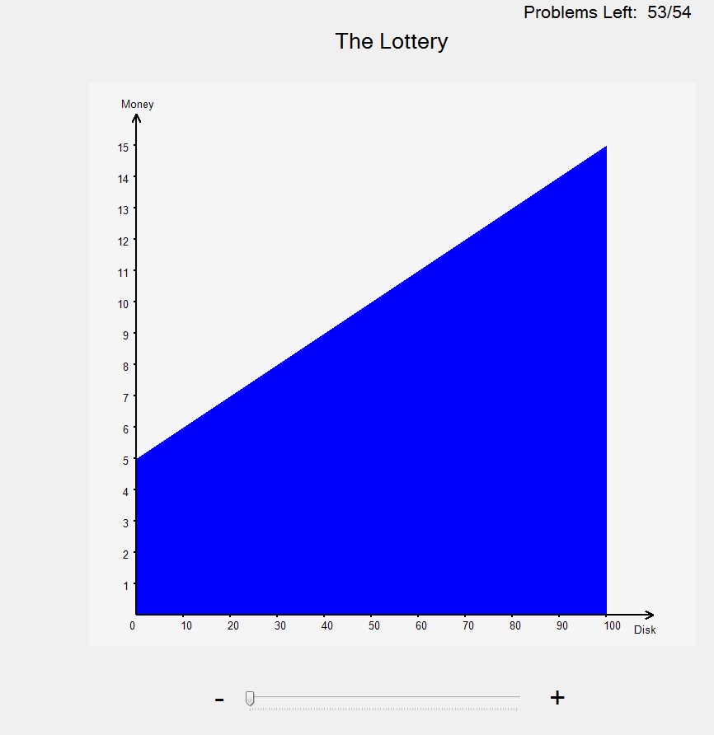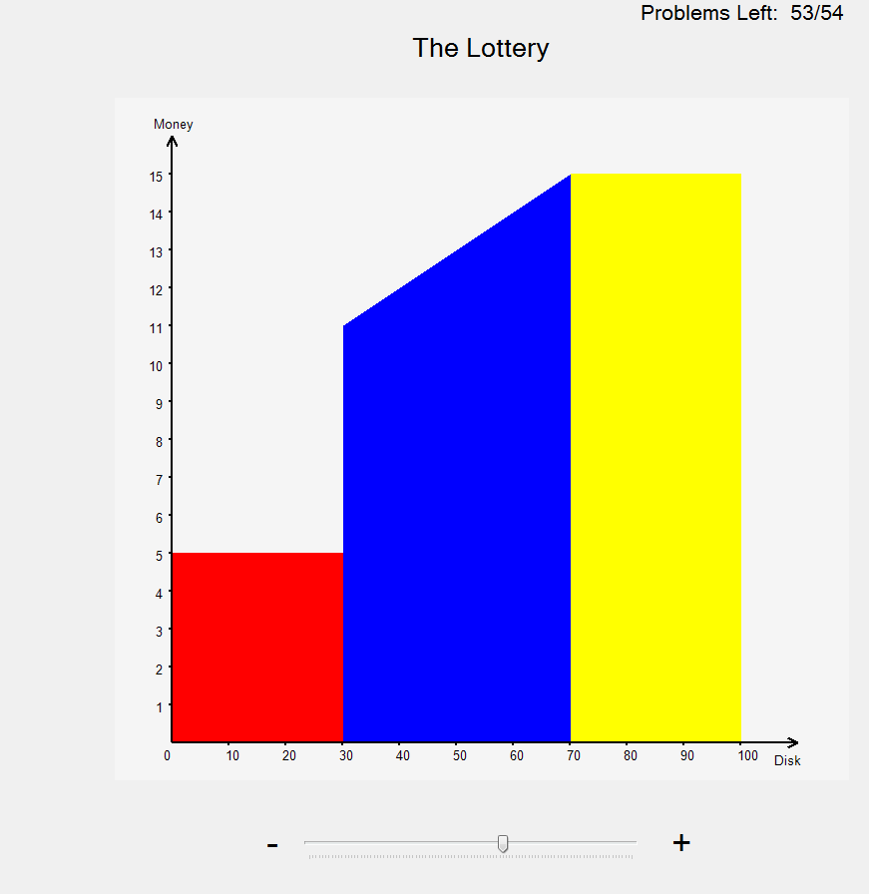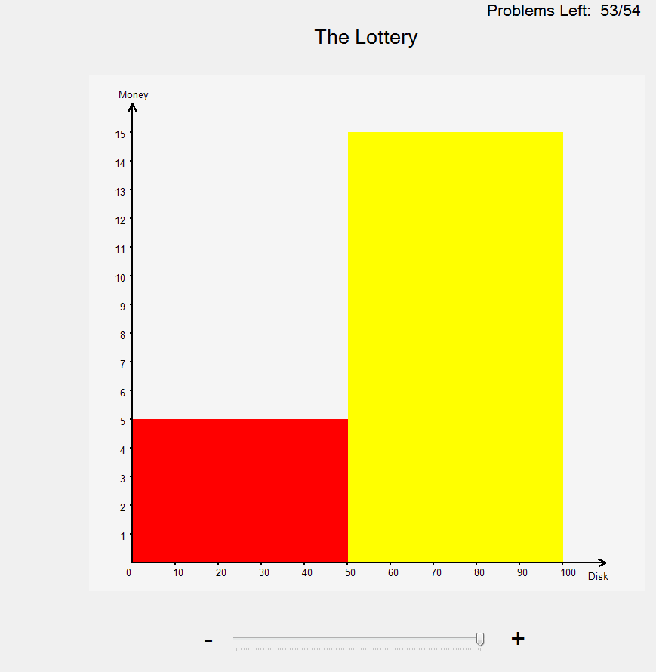

There will be a total of 54 problems in this part. In the upper-right corner of the screen you will be told how many problems remain. In each problem, you cannot take a decision until at least five seconds have elapsed, but you can take as long as you like.

The Payment Procedure
When you have completed the experiment, one of the experimenters will come to you. The experimenter will have a record of your decisions in each part of the experiment. You will then be asked to go into an adjoining room for payment. There will be another experimenter, who has on their computer all the decisions that you took. Then the following procedure will be followed.

- First you will draw ‒ without looking ‒ a disk out of a bag containing disks numbered from 1 to 4. The number on the disk will determine on which part of the experiment your payment will be determined.
- If the number on the disk is 1, then one of your answers in part 1 will determine your payment. You will draw ‒ without looking ‒ a disk from a bag containing disks numbered from 1 to 80 (the number of problems in part 1). This will determine the problem to be played out. The experimenter will then retrieve from the computer your decision on that problem. This will be a lottery. This will then be played out as described above (with you drawing ‒ without looking ‒ a disk out of a bag containing numbered disks from 1 to 100).
- If the number on the disk is 2, then one of your answers in part 2 will determine your payment. You will draw ‒ without looking ‒ a disk from a bag containing disks numbered from 1 to 48 (the number of problems in part 2). This will determine the problem to be played out. This will be a list. In each list there are 10 pairwise choices. You will then draw ‒ without looking ‒ a disk from a bag containing disks numbered from 1 to 10. This will determine a particular pairwise choice in that list. The experimenter will then retrieve from the computer your decision on that pairwise choice. This may be a certainty or a lottery. If it is a certainty, you will receive that amount of money. It is a lottery it will then be played out as described above (with you drawing ‒ without looking ‒ a disk out of a bag containing numbered disks from 1 to 100).
- If the number on the disk is 3, then one of your answers in part 3 will determine your payment. You will draw ‒ without looking ‒ a disk from a bag containing disks numbered from 1 to 81 (the number of problems in part 3). This will determine the problem to be played out. The experimenter will then retrieve from the computer your decision on that problem. This will be a lottery. This will then be played out as described above (with you drawing ‒ without looking ‒ a disk out of a bag containing numbered disks from 1 to 100).
- If the number on the disk is 4, then one of your answers in part 4 will determine your payment. You will draw ‒ without looking ‒ a disk from a bag containing disks numbered from 1 to 54 (the number of problems in part 4). This will determine the problem to be played out. The experimenter will then retrieve from the computer your decision on that problem. This will be a lottery. This will then be played out as described above (with you drawing ‒ without looking ‒ a disk out of a bag containing numbered disks from 1 to 100).

The show-up fee of £2.50 will be added to the payment as described above. You will be paid in cash, be asked to sign a receipt and then you are free to go.

If you have any questions, please ask one of the experimenters.

Thank you for your participation.

Wenting Zhou
John Hey
Daniela Di Cagno

October 2104

