The contribution of children’s parliament in ensuring the rights and well-being of children in Konso, Ethiopia

AMSALU LEMESSA TEREFE

Master’s of Philosophy in Childhood Studies
Norwegian Centre for Child Research
Norwegian University of Science and Technology
Trondheim, July 2010

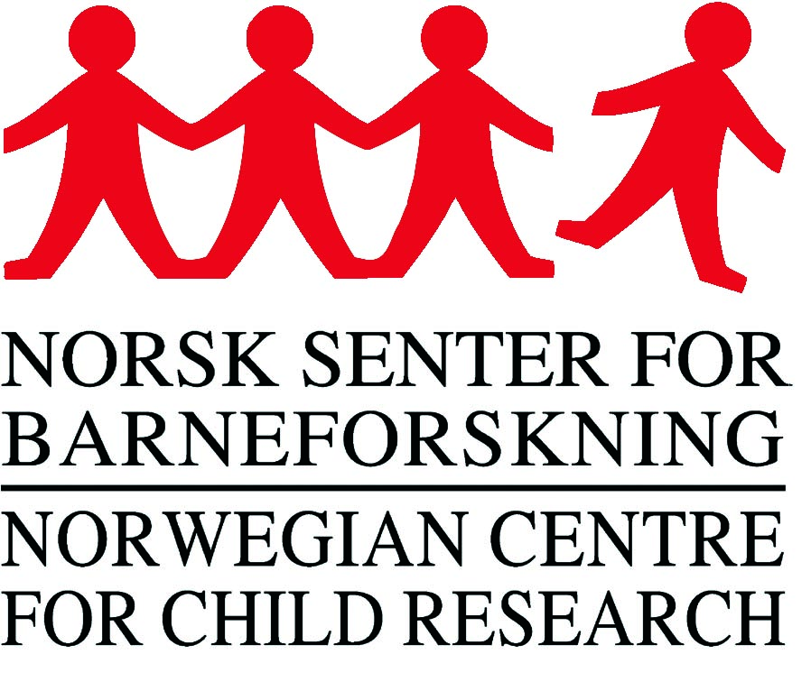


Abstract
The goal of this research was to investigate the significance of children’s parliament for the effective realization of children’s rights and for the well-being of children in Konso. Accordingly, the research has sought to answer the research questions related to reason of establishing children’s parliament in Konso district (wereda); major goals, duties, and activities of the parliament; achievements, interventions, challenges and opportunities of the parliament; and Konso children’s perception of their rights.
The research was conducted in two research sites, namely Addis Ababa and Konso Special Wereda. The research design adopted was qualitative research method which was selected based on theoretical framework adopted in this research, research questions and participants of this research. The informants of the research include children (both members and non-members of the parliament), parents, teachers, and leaders (staffs) of different institutions which have direct and indirect relation with Konso children’s parliament. So as to select these subjects, three non-probability sampling methods, such as availability, purposive and snow-ball sampling methods were used. Similarly, to collect data four data gathering tools, such as in-depth interview, focus group discussion, participant observation and field notes, documentary analysis were employed. The data were transcribed and analyzed through qualitative analysis methods by taking context of the research and the perspective of informants into ground.
Accordingly, the research has found out that Konso children’s parliament is playing significant role in realizing children’s rights, and in shaping and reshaping the socio-economics of Konso Special Wereda. Its active participation has brought some incredible changes, particularly in areas of children’s schooling, promoting children’s rights and responsibilities, and violence against children. Based on the findings, the research has concluded that if they are well-founded and assisted, children’s parliaments will be the appropriate means of realizing children’s participation rights. Aside creating awareness on children’s rights, protecting children’s well-being, and monitoring the proper implementation of children’s rights, children’s parliaments are agents of social change, especially in Contexts like Konso where societies are less exposed to modern social and economical changes.

